**EXPERIMENT - 1**

**AIM:**

Create a webpage with HTML describing your department. Use paragraph and list tags.

**THEORY:**

**HTML**

HTML is an acronym which stands for **Hyper Text Markup Language** which is used for creating web pages and web applications. Let's see what is meant by Hypertext Markup Language, and Web page.

**Hyper Text:** Hyper Text simply means "Text within Text." A text has a link within it, is a hypertext. Whenever you click on a link which brings you to a new webpage, you have clicked on a hypertext. Hyper Text is a way to link two or more web pages (HTML documents) with each other.

**Markup language:** A markup language is a computer language that is used to apply layout and formatting conventions to a text document. Markup language makes text more interactive and dynamic. It can turn text into images, tables, links, etc.

**Paragraph Tag**

The HTML **<p> element defines a paragraph**. A paragraph always starts on a new line, and browsers automatically add some white space (a margin) before and after a paragraph.

**List Tag**

HTML Lists are used to specify lists of information. All lists may contain one or more list elements. There are three different types of HTML lists:

1. Ordered List or Numbered List (OL)
2. Unordered List or Bulleted List (UL)
3. Description List or Definition List (DL)

# Ordered List or Numbered List

In the ordered HTML lists, all the list items are marked with numbers by default. It is known as numbered list also. The ordered list starts with <ol> tag and the list items start with <li> tag.

# Unordered List or Bulleted List

In HTML Unordered list, all the list items are marked with bullets. It is also known as bulleted list also. The Unordered list starts with <ul> tag and list items start with the <li> tag.

# Description List or Definition List

HTML Description list is also a list style which is supported by HTML and XHTML. It is also known as definition list where entries are listed like a dictionary or encyclopaedia. The HTML definition list contains following three tags:

1. **<dl> tag** defines the start of the list.
2. **<dt> tag** defines a term.
3. **<dd> tag** defines the term definition (description).

**CODE:**

**HTML:**

<!DOCTYPE html>

<html lang="en">

<head>

<meta charset="UTF-8">

<meta http-equiv="X-UA-Compatible" content="IE=edge">

<meta name="viewport" content="width=device-width, initial-scale=1.0">

<title>Delhi technological University</title>

</head>

<body>

<div class="header">

<div class="details">

<h1 class="header-title">Delhi Technological University</h1>

<h3 class="dept-header"> &nbsp;&nbsp;Computer Science and Engineering</h3>

</div>

</div>

<div class="section">

<ul>

<li>The Department of Computer Science & Engineering is an excellent centre of learning providing in-depth technical knowledge and opportunities for innovation and research with up-to-date computing facilities.

<li>

The Department’s mission is to advance, evolve, and enhance computer science fundamentals to build researchers and students’ intellectual capital. The Department has a lively and vibrant student body and many distinguished faculties with PhD/PhD pursuing. The Department also offers several attractive national/international exposures to students in terms of Industrial Internship, Minor Project and Major Project for UG Programs.

</li>

<li>

The Department is cherished and nurtured by various student clubs and committees along with research groups. These clubs offer students the chance to gain experience in their interest areas and network with their peers. Each research group holds regular meetings and hold seminars to discuss current research topics and results. These research groups are specialized in various domains like Machine Learning, Databases, Artificial Intelligence, Design and Analysis of Algorithms, Compiler Design, Web Engineering, Cryptography, Network Security and Computer Networks. The Department’s faculty members have published more than 30 research papers in reputed international and national journals and presented 50 research papers in various International and National Conferences.

</li>

<li>The Computer Science & Engineering Department is equipped with various labs like Software Testing & Quality Assurance Lab, Data Structures Lab, Computer Graphics Lab, Database Management System Lab, Operating System Lab, Software Engineering Lab, Programming Lab, Design & Algorithm Lab, Data Communication & Networking Lab, Project Lab, and Computer Organization & Architecture Lab.

</ul>

</div>

</body>

</html>

**OUTPUT:**

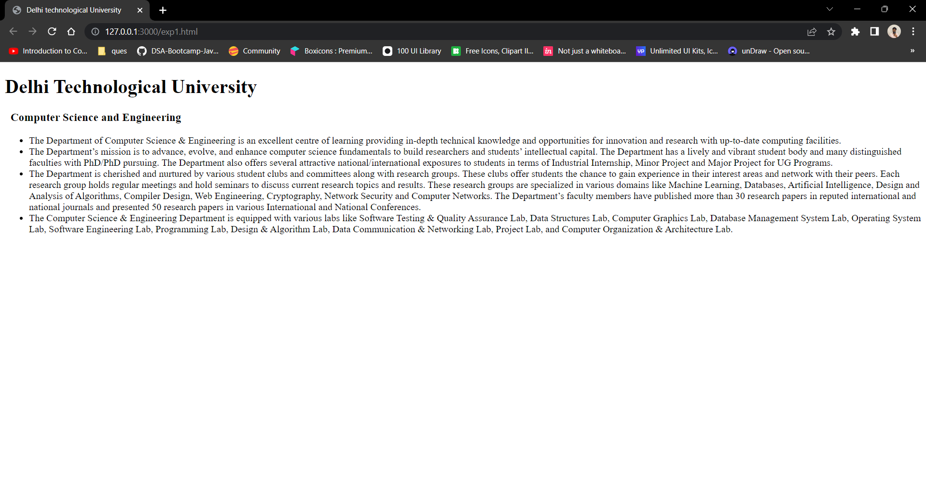

**CONCLUSION:**

Through this experiment, paragraphs tags and lists were explored in HTML and a webpage was created using the same.

**EXPERIMENT - 2**

**AIM:**

Apply various color to suitability distinguish key words. Also apply font styling like italics, underline and two other fonts to words you find appropriate. Also use header tags.

**THEORY:**

# CSS Color Property

The color property in CSS is used to set the color of HTML elements. Typically, this property is used to set the background color or the font color of an element.

## HTML Style

HTML Style is used to change or add the style on existing HTML elements. There is a default style for every HTML element e.g., background color is white, text color is black etc.

The style attribute can by used with any HTML tag. To apply style on HTML tag, you should have the basic knowledge of css properties e.g. color, background-color, text-align, font-family, font-size etc.

**CODE:**

**HTML:**

<!DOCTYPE html>

<html lang="en">

<head>

<meta charset="UTF-8" />

<meta http-equiv="X-UA-Compatible" content="IE=edge" />

<meta name="viewport" content="width=device-width, initial-scale=1.0" />

<link rel="preconnect" href="https://fonts.googleapis.com" />

<link rel="preconnect" href="https://fonts.gstatic.com" crossorigin />

<link href="https://fonts.googleapis.com/css2?family=Roboto:wght@300;500;700&display=swap"

rel="stylesheet"/>

<link href="https://fonts.googleapis.com/css2?family=Poppins:wght@400;500;700&display=swap" rel="stylesheet">

<link rel="stylesheet" href="style.css">

<title>Delhi technological University</title>

</head>

<body>

<div class="header">

<div class="details">

<h1 class="header-title">Delhi Technological University</h1>

<h4 class="dept-header">- Computer Science and Engineering</h4>

</div>

</div>

<div class="section">

<ul>

<li>

The

<b style="color: cadetblue">Department of Computer Science & Engineering</b >

is an excellent centre of learning providing in-depth technical

knowledge and opportunities for innovation and research with

up-to-date computing facilities.

</li>

<li>

The Department’s mission is to <i>advance, evolve, and enhance computer science fundamentals to build researchers and students’</i > intellectual capital. The Department has a lively and vibrant student body and many distinguished faculties with PhD/PhD pursuing. The Department also offers several attractive national/international exposures to students in terms of Industrial Internship, Minor Project and Major Project for UG Programs.

</li>

<li>

The Department is cherished and nurtured by

<b style="color: cadetblue"

>various student clubs and committees along with research groups</b

>. These clubs offer students the chance to gain experience in their

interest areas and network with their peers. Each research group holds

regular meetings and hold seminars to discuss current research topics

and results. These research groups are specialized in various domains

like Machine Learning, Databases, Artificial Intelligence, Design and

Analysis of Algorithms, Compiler Design, Web Engineering,

Cryptography, Network Security and Computer Networks. The Department’s

faculty members have published more than 30 research papers in reputed

international and national journals and presented 50 research papers

in various International and National Conferences.

</li>

<li>

The Computer Science & Engineering Department is equipped with

<b style="color: cadetblue">various labs</b> like Software Testing &

Quality Assurance Lab, Data Structures Lab, Computer Graphics Lab,

Database Management System Lab, Operating System Lab, Software

Engineering Lab, Programming Lab, Design & Algorithm Lab, Data

Communication & Networking Lab, Project Lab, and Computer Organization

& Architecture Lab.

</li>

</ul>

</div>

</body>

</html>

**CSS:**

*{

margin: 0;

padding:0;

box-sizing: border-box;

font-family: 'Roboto', sans-serif;

}

body{

background-color: azure;

}

.header{

font-family: 'Poppins', sans-serif;

display: flex;

background-color: #16213E;

color:aliceblue;

padding : 25px;

font-weight: 700;

}

.details{

padding:20px;

}

.section{

padding:40px;

font-size: 20px;

font-weight: 300;

}

.header-title{

display: inline-block;

text-decoration: underline;

}

**OUTPUT:**

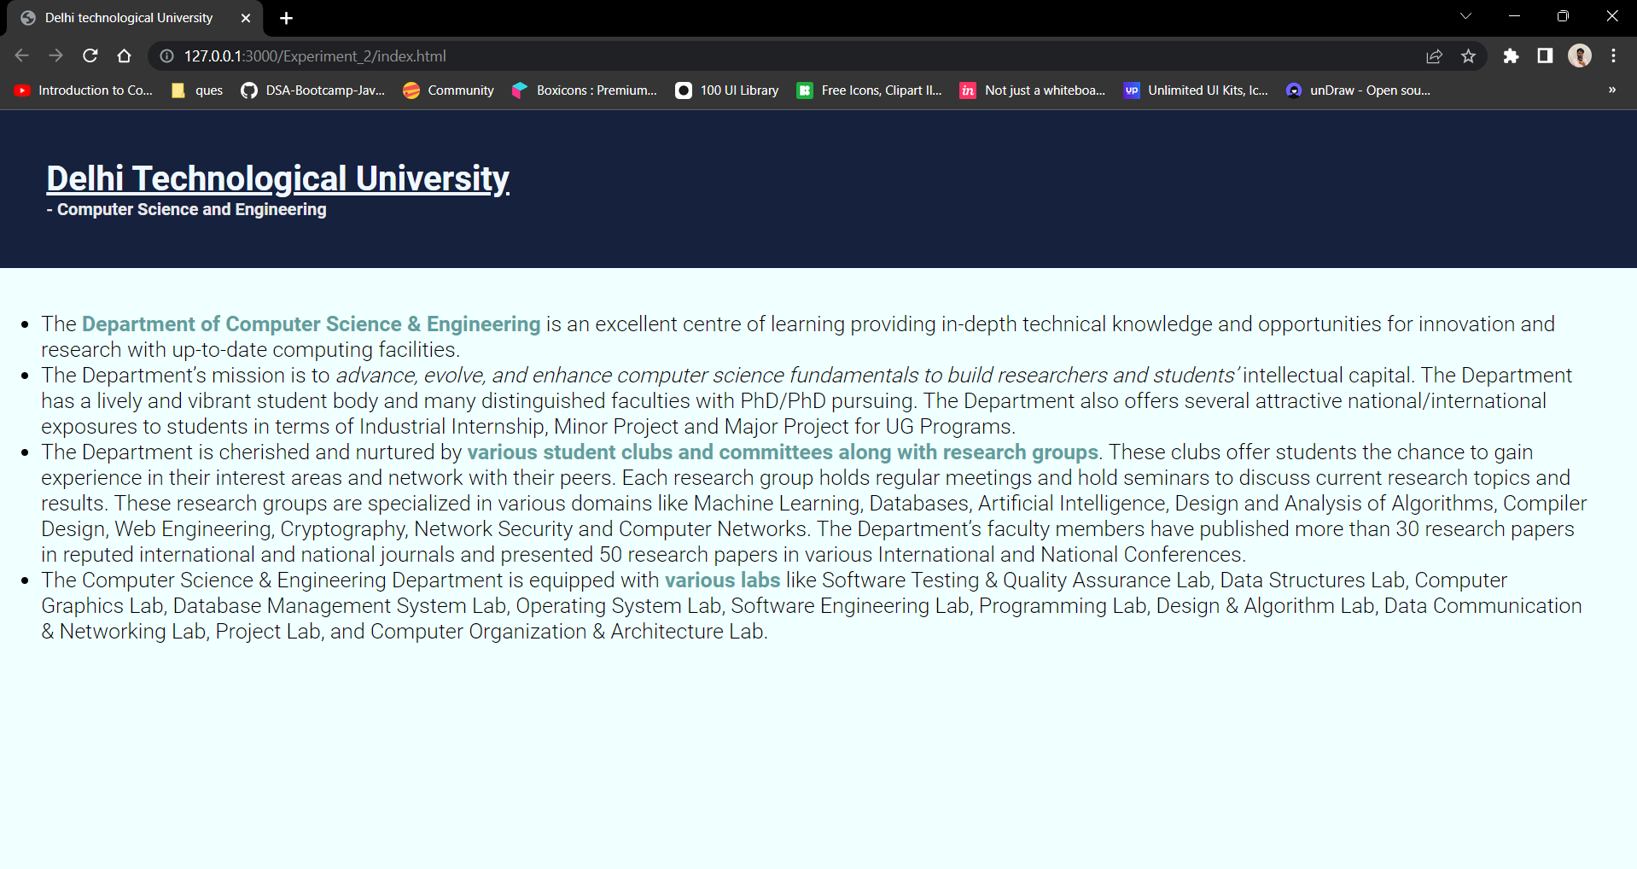

**CONCLUSION:**

Through this experiment, some font related and text related tags were explored in HTML, along with that some basic CSS properties were also explored and a webpage was created using the same.

**EXPERIMENT - 3**

**AIM:**

Insert an image and create a link such that clicking on image takes user to other page. Change the background colour of the page. At the bottom create a link to take user to the top of the page.

**THEORY:**

**IMG TAG**

The <img> tag is used to embed an image in an HTML page.

Images are not technically inserted into a web page; images are linked to web pages. The <img> tag creates a holding space for the referenced image.

The <img> tag has two required attributes:

1. src - Specifies the path to the image
2. alt - Specifies an alternate text for the image, if the image for some reason cannot be displayed

**A TAG**

The <a> tag defines a hyperlink, which is used to link from one page to another. The most important attribute of the <a> element is the href attribute, which indicates the link's destination.

By default, links will appear as follows in all browsers:

* An unvisited link is underlined and blue
* A visited link is underlined and purple
* An active link is underlined and red

**CODE:**

**HTML:**

<!DOCTYPE html>

<html lang="en">

<head>

<meta charset="UTF-8" />

<meta http-equiv="X-UA-Compatible" content="IE=edge" />

<meta name="viewport" content="width=device-width, initial-scale=1.0" />

<link rel="stylesheet" href="style.css" />

<link rel="stylesheet" href="https://fonts.googleapis.com/css2?family=Material+Symbols+Outlined:opsz,wght,FILL,GRAD@48,400,0,0" />

<link rel="preconnect" href="https://fonts.googleapis.com" />

<link rel="preconnect" href="https://fonts.gstatic.com" crossorigin />

<link

href="https://fonts.googleapis.com/css2?family=Roboto:wght@300;500;700&display=swap"

rel="stylesheet"

/>

<link rel="shortcut icon" href="image/dtu.png" type="image/x-icon" />

<title>Delhi technological University</title>

</head>

<body>

<div class="header" id="head">

<a href="https://dtu.ac.in/"

><img

src="image/dtu.png"

class="logo"

alt="Delhi Technological University"

/></a>

<div class="details">

<h1 class="header-title">Delhi Technological University</h1>

<h4 class="dept-header">- Computer Science and Engineering</h4>

</div>

</div>

<div class="section">

<ul>

<li>

The

<b style="color: cadetblue"

>Department of Computer Science & Engineering</b

>

is an excellent centre of learning providing in-depth technical

knowledge and opportunities for innovation and research with

up-to-date computing facilities.

</li>

<li>

The Department’s mission is to

<i

>advance, evolve, and enhance computer science fundamentals to build

researchers and students’</i

>

intellectual capital. The Department has a lively and vibrant studentbody and many distinguished faculties with PhD/PhD pursuing. The Department also offers several attractive national/international

exposures to students in terms of Industrial Internship, Minor Project and Major Project for UG Programs.

</li>

<li>

The Department is cherished and nurtured by

<b style="color: cadetblue">

various student clubs and committees along with research groups</b >. These clubs offer students the chance to gain experience in their interest areas and network with their peers. Each research group holds regular meetings and hold seminars to discuss current research topics and results. These research groups are specialized in various domains like Machine Learning, Databases, Artificial Intelligence, Design andAnalysis of Algorithms, Compiler Design, Web Engineering, Cryptography, Network Security and Computer Networks. The Department’s faculty members have published more than 30 research papers in reputedinternational and national journals and presented 50 research papersin various International and National Conferences.

</li>

<li>

The Computer Science & Engineering Department is equipped with

<b style="color: cadetblue">various labs</b> like Software Testing & Quality Assurance Lab, Data Structures Lab, Computer Graphics Lab,Database Management System Lab, Operating System Lab, Software ngineering Lab, Programming Lab, Design & Algorithm Lab, Data Communication & Networking Lab, Project Lab, and Computer Organization& Architecture Lab.

</li>

</ul>

</div>

<div class="section">

<h2>About DTU</h2>

<ul>

<li>Delhi Technological University (Delhi College of Engineering) operated from the Kashmiri Gate campus in the heart of Old Delhi until 1989, when construction began at the New Campus at Bawana Road in May. Moving of operations from Kashmiri Gate to the new 164 acres at Bawana Road began in 1995, and the new campus formally started classes for all four years of study starting 1999.</li>

<li>

The new DTU campus is well connected by road. Facilities include a library, a computer centre, a sports complex, eight boys' hostels, six girls' hostels, and a married couples' hostel. The campus has residential facilities for faculty and staff. The campus has an auditorium and two open-air theatres out of which one is called the OAT (Open-air Theatre) and the other is called the Mini OAT (Mini open-air theatre).

</li>

<li>

In 2010, the DTU came up with a plan to make the campus environment friendly which included, barring entry of vehicles in the campus, generation of one-third of the energy from alternative sources and on designing new buildings as per "green architecture concept".

</li>

<li>

DTU has opened up a campus in Vivek Vihar, East Delhi named "University School of Management and Entrepreneurship (USME)" in 2017. The new campus offers management courses for graduation and post graduation. Currently, the USME, east campus of DTU offers courses in MBA, MBA business analytics, BBA, and BA in Economics. USME offers 60 seats for MBA students and 30 seats for MBA business analytics program. Admission to MBA is decided by CAT score and further by rigorous group discussion and personal interviews. Moreover, there are 120 seats for BBA and BA (hons) Economics each. The admission to the courses is merit-based.

</li>

</ul>

</div>

<a href="#head" class="btt-btn"><span class="material-symbols-outlined">

vertical_align_top

</span> Back to Top</a>

</body>

</html>

**CSS:**

*{

margin: 0;

padding:0;

box-sizing: border-box;

font-family: 'Roboto', sans-serif;

}

body{

background-color: azure;

}

.logo{

width: 100px;

cursor: pointer;

}

.header{

display: flex;

background-color: #16213E;

color:aliceblue;

padding : 25px;

font-weight: 700;

}

.details{

padding:20px;

}

.section{

padding:40px;

font-size: 20px;

font-weight: 300;

}

.dept-header{

color: #e8e8e8;

}

.header-title{

display: inline-block;

text-decoration: underline;

}

.section{

margin: 20px;

}

.section li{

margin-bottom: 20px;

}

.btt-btn{

background-color: #A1C298;

width: 150px;

height:40px;

display: flex;

margin:15px;

text-decoration: none;

align-items:center;

justify-content:center;

border-radius: 5px;

color:white;

}

**OUTPUT:**

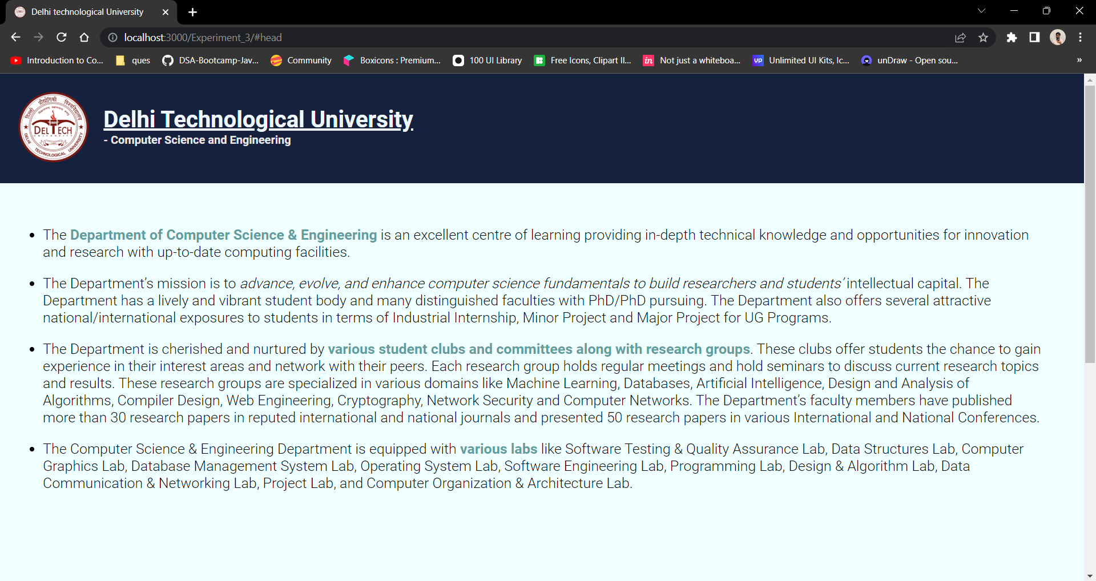

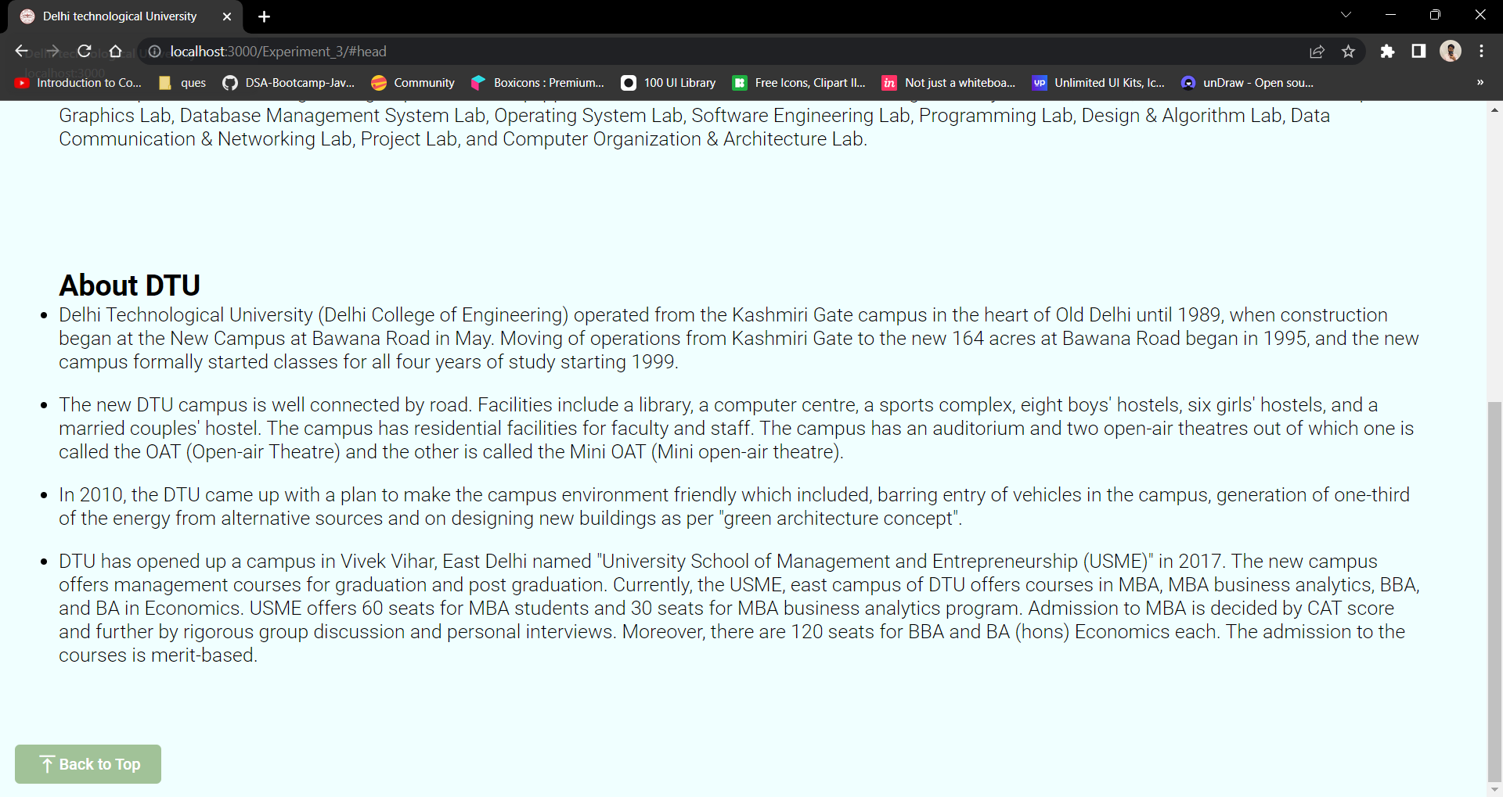

**CONCLUSION:**

Through this experiment, some links and image related tags were explored in HTML, along with that some basic CSS properties were also explored and a webpage was created using the same.

**EXPERIMENT - 4**

**AIM:**

Design a single page web site for a university containing a description of the courses offered, it should also contain some general information about the university such as its history, the campus and its unique features the page should be coloured and each section should have different colour.

**THEORY:**

**Nav Bar in HTML**

The <nav> tag defines a set of navigation links. Notice that NOT all links of a document should be inside a <nav> element. The <nav> element is intended only for major blocks of navigation links.

Browsers, such as screen readers for disabled users, can use this element to determine whether to omit the initial rendering of this content.

**Footer in HTML**

The <footer> tag defines a footer for a document or section.

A <footer> element typically contains:

1. authorship information
2. copyright information
3. contact information
4. sitemap
5. back to top links
6. related documents

You can have several <footer> elements in one document.

**Section tag in HTML**

The section tag is used when requirements of two headers or footers or any other section of documents needed. Section tag grouped the generic block of related contents. The main advantage of the section tag is, it is a semantic element, which describes its meaning to both browser and developer.

**HTML Class Attribute**

The class attribute specifies one or more class names for an element.

The class attribute is mostly used to point to a class in a style sheet. However, it can also be used by a JavaScript (via the HTML DOM) to make changes to HTML elements with a specified class.

**ID in HTML**

The id attribute specifies a unique id for an HTML element. The value of the id attribute must be unique within the HTML document. The id attribute is used to point to a specific style declaration in a style sheet. It is also used by JavaScript to access and manipulate the element with the specific id.

The syntax for id is: write a hash character (#), followed by an id name. Then, define the CSS properties within curly braces {}.

**CODE:**

**HTML:**

<!DOCTYPE html>

<div lang="en">

<head>

<meta charset="UTF-8">

<meta name="viewport" content="width=device-width, initial-scale=1.0">

<link rel="stylesheet" type="text/css" href="style.css">

<link href="https://fonts.googleapis.com/css2?family=Lato:wght@100;300&display=swap" rel="stylesheet">

<title>Delhi Technological University</title>

</head>

<body>

<div>

<div id="cover">

<img src="img/dtu-logo.png"/>

<p>

Delhi Technological University

</p>

<h2>( Formerly Delhi College of Engineering )</h2>

</div>

</div>

<div class="about">

<div class="container">

<div class="text">

<h2>

About Delhi Technological University

</h2>

<p>

"75 years of Tradition of excellence in Engineering & Technology Education, Research and

Innovations" Delhi College of Engineering, (initially established with the name – Delhi

Polytechnic) came into existence in the year 1941 to cater the needs of Indian industries for trained technical manpower with practical experience and sound theoretical knowledge. The institution was set up at historic Kashmere Gate campus as a follow up of the Wood and Abott Committee of 1938. It comprised of a multi disciplinary and multi level institution offering wide ranging programmes in engineering, technology, arts and sculpture, architecture, pharmacy and commerce.

</p>

</div>

<div class="image">

<img src="img/dtu-gate.jpeg" alt="The Image can't be displayed" title="DTU Entrance">

</div>

</div>

</div>

<div class="campus">

<div class="container">

<div class="image">

<img src="img/dsm.png" alt="The Image can't be displayed" title="Indian History">

</div>

<div class="text">

<h2>

Campus

</h2>

<p>

DTU has 164 acres of a lush gree, tech-savvy main campus, with approximately 1,56,000 square metres of built up area, 15 academic departments, research centres, and residences for students, Faculty and staff. It is a zero discharge campus having Sewage Treatment Plant and Waste to Energy Plant in the campus itself. The University, as on date, has 11,019 students in its undergraduate, postgraduate and Ph.D programs.

</p>

</div>

</div>

</div>

<div class="courses">

<div class="container">

<div class="courses-header">

<h2>Courses Offered</h2>

</div>

<div class="courses-body">

<div class="course">

<div class="image">

<img src="img/btech.jpg" alt="The Image can't be displayed" title="Indian History">

</div>

<div class="caption">

<h3>B.Tech</h3>

</div>

<div class="text">

<p>

B.Tech is a professional four years undergraduate degree programme in technology

awarded to candidates after completion of the school study. The college offers B.Tech in

15 departments

</p>

</div>

</div>

<div class="course">

<div class="image">

<img src="img/mtech.webp" alt="The Image can't be displayed" title="Indian History">

</div>

<div class="caption">

<h3>M.Tech</h3>

</div>

<div class="text">

<p>

M.Tech is a professional two years postgraduate master degree programme in technology awarded to candidates after completion of two years of study in the discipline of engineering/technology.

</p>

</div>

</div>

<div class="course">

<div class="image">

<img src="img/phd2.jpeg" alt="The Image can't be displayed" title="Indian History">

</div>

<div class="caption">

<h3>Ph.D</h3>

</div>

<div class="text">

<p>

The University offers Ph.D. programme in wide range of areas in Engineering, Sciences

and Humanities. The academic programme of Ph.D. degree is broad-based and

involves a course credit requirement.

</p>

</div>

</div>

<div class="course">

<div class="image">

<img src="img/bdes.jpg" alt="The Image can't be displayed" title="Indian History">

</div>

<div class="caption">

<h3>B.Des</h3>

</div>

<div class="text">

<p>

DTU has decided to provide facilities for excellent design education and training to suit the needs of the society. Department of Design is envisioned to pursue excellence in design thinking.

</p>

</div>

</div>

</div>

</div>

</div>

</body>

**CSS:**

* {

margin: 0;

padding: 0;

font-family: 'Lato', Arial, Helvetica, sans-serif;

}

body {

display: flex;

flex-direction: column;

flex: 1;

background-color: #381407;

}

#cover {

display: flex;

flex-direction: column;

height: 100vh;

justify-content: center;

align-items: flex-start;

background :linear-gradient(0deg, rgba(56,20,7,1) 5%, rgba(131, 99, 87, 0.8) 100%), url('../img/IMG_20190409_152154068.jpg');

background-size: cover;

background-position: center;

background-repeat: no-repeat;

}

#cover p, #cover h2 {

margin-left: 25px;

color: rgb(255, 255, 255);

text-transform: uppercase;

}

#cover p {

font-weight: 100;

font-size: 75px;

}

#cover img {

margin-left: 25px;

width: 200px;

}

.container {

color: #fff;

display: flex;

flex-direction: row;

flex-wrap: wrap;

padding: 2% 0;

border-radius: 20px;

margin: 2% 10%;

background: #852907;

}

.campus .container {

background: #9C1300;

}

.text {

flex-wrap: wrap;

display: flex;

flex-direction: column;

justify-content: center;

padding: 0 5%;

flex: 1;

}

.courses .container {

background: #915100;

flex-direction: column;

justify-content: center;

align-items: center;

}

.courses-header {

font-size: 20px;

}

.courses-body {

padding: 2% 0;

display: flex;

flex-direction: row;

justify-content: center;

align-items: center;

}

.courses-body .text p {

font-size: 15px;

}

.courses-body .image {

display: flex;

flex: 1;

padding: 5%;

}

.courses-body .image img {

width: 100%;

}

.course {

flex: 1;

display: flex;

flex-direction: column;

justify-content: center;

align-items: center;

}

.caption {

margin: 1% 0;

}

.text p {

font-size: 15px;

text-align: justify;

}

.image {

flex-wrap: wrap;

flex: 1;

justify-content: center;

align-items: center;

display: flex;

}

.image img {

width: 75%;

border-radius: 20px;

}

.button {

text-decoration: none;

font-size: large;

color: #fff;

background-color: #a03109;

padding: 4% 8%;

border-radius: 50px;

transition: all 0.2s;

}

.button:hover {

background-color: #551c08;

}

#links {

display: flex;

flex-direction: row;

}

.link {

padding: 5% 5%;

flex-direction: row;

justify-content: center;

display: flex;

flex: 1;

}

**OUTPUT:**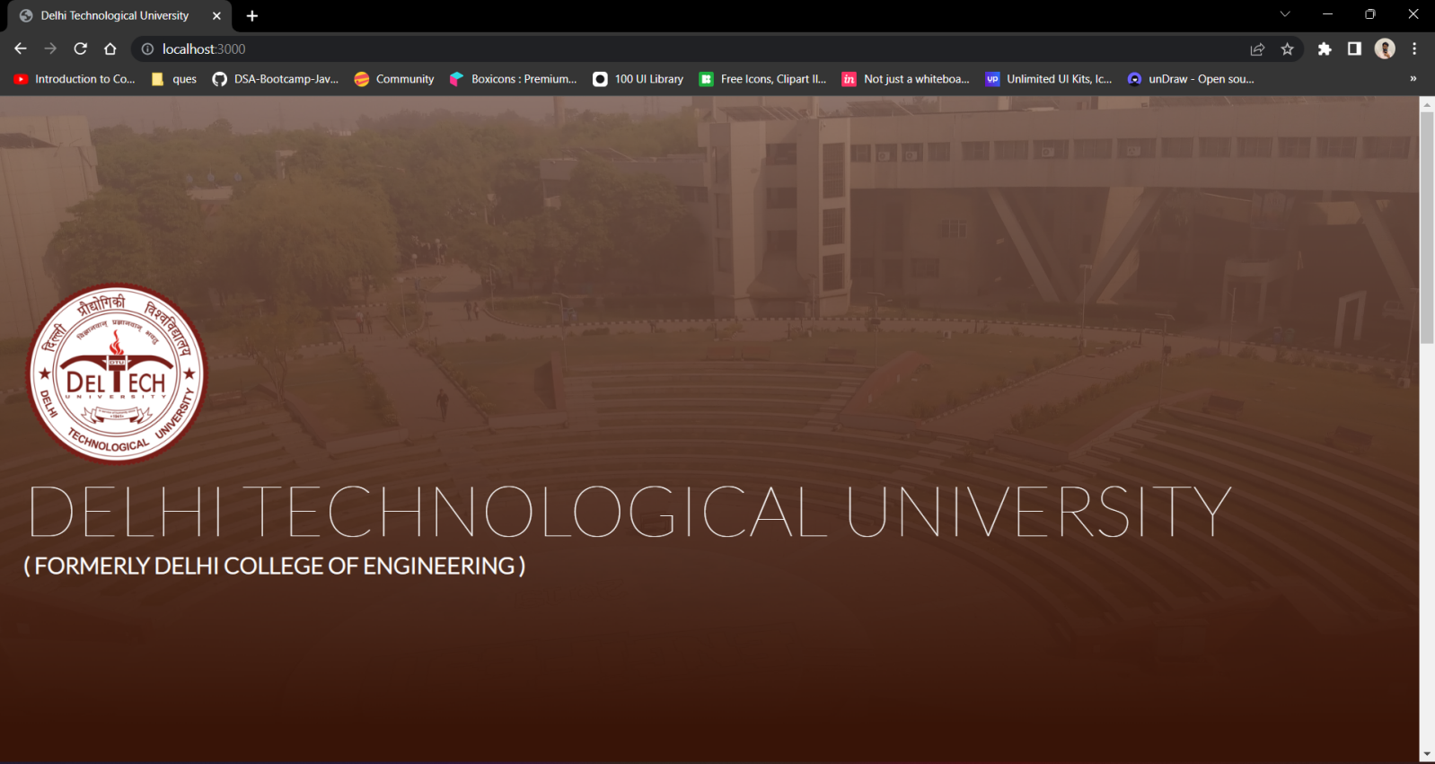

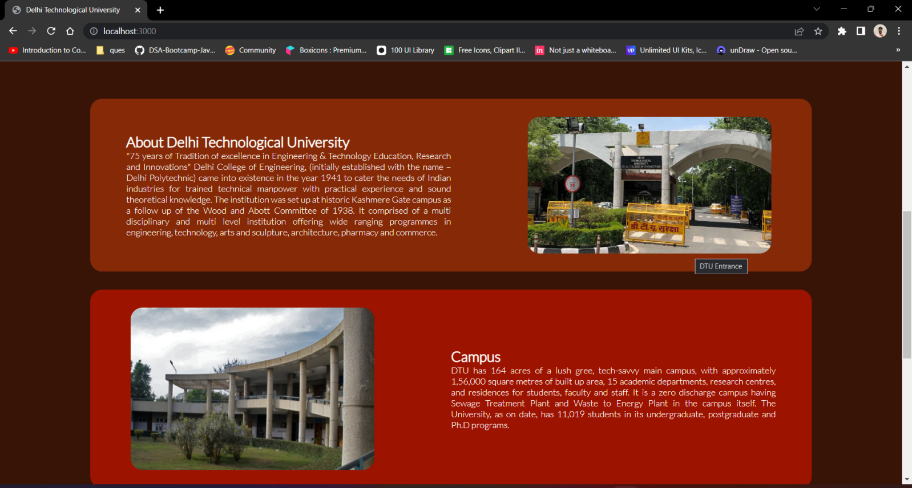

**CONCLUSION:**

Through this experiment, Image related tags were explored in HTML, along with that CSS properties were also explored and a webpage was created using the same.

**EXPERIMENT - 5**

**AIM:**

Design page that has 5 equal columns the table should look the same in all screen resolution.

**THEORY:**

**Flexbox-CSS 1-D Layout**

The Flexible Box Module, usually referred to as flexbox, was designed as a one-dimensional layout model, and as a method that could offer space distribution between items in an interface and powerful alignment capabilities.

**Main and cross axis:**

The main axis is defined by flex-direction, which has four possible values:

1. row
2. row-reverse
3. column
4. column-reverse

The cross axis runs perpendicular to the main axis, therefore if your flex-direction (main axis) is set to row or row-reverse the cross axis runs down the columns.

**CODE:**

**HTML:**

<!DOCTYPE html>

<html lang="en">

<head>

<meta charset="UTF-8">

<meta name="viewport" content="width=device-width, initial-scale=1.0">

<link rel="stylesheet" type="text/css" href="./style.css">

<link href="https://fonts.googleapis.com/css2?family=Lato:wght@100;300&display=swap" rel="stylesheet">

<title>Table</title>

</head>

<body>

<div class="table">

<div class="column">

<div class="header">

Column 1

</div>

<div class="data">

Lorem ipsum dolor sit amet, consectetur adipiscing elit. In a massa a est gravida gravida. Vivamus velien sem. Mauris condimentum massa a rhoncus placerat. Aenean efficitur eget justo at iaculis. Integer et dolor nisi. Sed consequat fermentum enim, ac sodales nisi consequat vel. Nunc rhoncus porta elit a egestas. Nulla gravida vitae nulla et eleifend. Vestibulum id leo felis.

</div>

</div>

<div class="column">

<div class="header">

Column 2

</div>

<div class="data">

Lorem ipsum dolor sit amet, consectetur adipiscing elit. In a massa a est gravida gravida. Vivamus vel sapien sem. Mauris condimentum massa a rhoncus placerat. Aenean efficitur eget justo at iaculis. Integer et dolor nisi. Sed consequat fermentum enim, ac sodales nisi consequat vel. Nunc rhoncus porta elit a egestas. Nulla gravida vitae nulla et eleifend. Vestibulum id leo felis.

</div>

</div>

<div class="column">

<div class="header">

Column 3

</div>

<div class="data">

Lorem ipsum dolor sit amet, consectetur adipiscing elit. In a massa a est gravida gravida. Vivamus vel sapien sem. Mauris condimentum massa a rhoncus placerat. Aenean efficitur eget justo at iaculis. Integer et dolor nisi. Sed consequat fermentum enim, ac sodales nisi consequat vel. Nunc rhoncus porta elit a egestas. Nulla gravida vitae nulla et eleifend. Vestibulum id leo felis.

</div>

</div>

<div class="column">

<div class="header">

Column 4

</div>

<div class="data">

Lorem ipsum dolor sit amet, consectetur adipiscing elit. In a massa a est gravida gravida. Vivamus vel sapien sem. Mauris condimentum massa a rhoncus placerat. Aenean efficitur eget justo at iaculis. Integer et dolor nisi. Sed consequat fermentum enim, ac sodales nisi consequat vel. Nunc rhoncus porta elit a egestas. Nulla gravida vitae nulla et eleifend. Vestibulum id leo felis.

</div>

</div>

<div class="column">

<div class="header">

Column 5

</div>

<div class="data">

Lorem ipsum dolor sit amet, consectetur adipiscing elit. In a massa a est gravida gravida. Vivamus vel sapien sem. Mauris condimentum massa a rhoncus placerat. Aenean efficitur eget justo at iaculis. Integer et dolor nisi. Sed consequat fermentum enim, ac sodales nisi consequat vel. Nunc rhoncus porta elit a egestas. Nulla gravida vitae nulla et eleifend. Vestibulum id leo felis.

</div>

</div>

</div>

</body>

</html>

**CSS:**

* {

margin: 0;

padding: 0;

font-family: 'Lato', Arial, Helvetica, sans-serif;

}

body {

display: flex;

flex-direction: column;

justify-content: center;

align-items: center;

height: 100vh;

color: #fff;

background-color: black;

}

.table {

background-color: rgb(38, 90, 90);

display: flex;

flex-direction: row;

justify-content: center;

align-items: center;

padding: 2% 5%;

}

.column {

padding: 0 2%;

display: flex;

height: 100%;

flex-direction: column;

justify-content: space-between;

align-items: center;

border: 2px solid #ccc;

}

.header, .data {

display: flex;

}

.header {

flex: 1;

}

.data {

flex: 4;

}

**OUTPUT:**

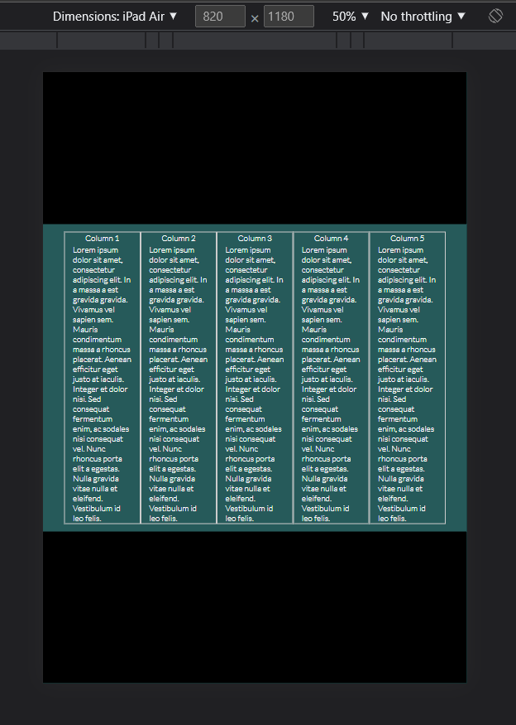

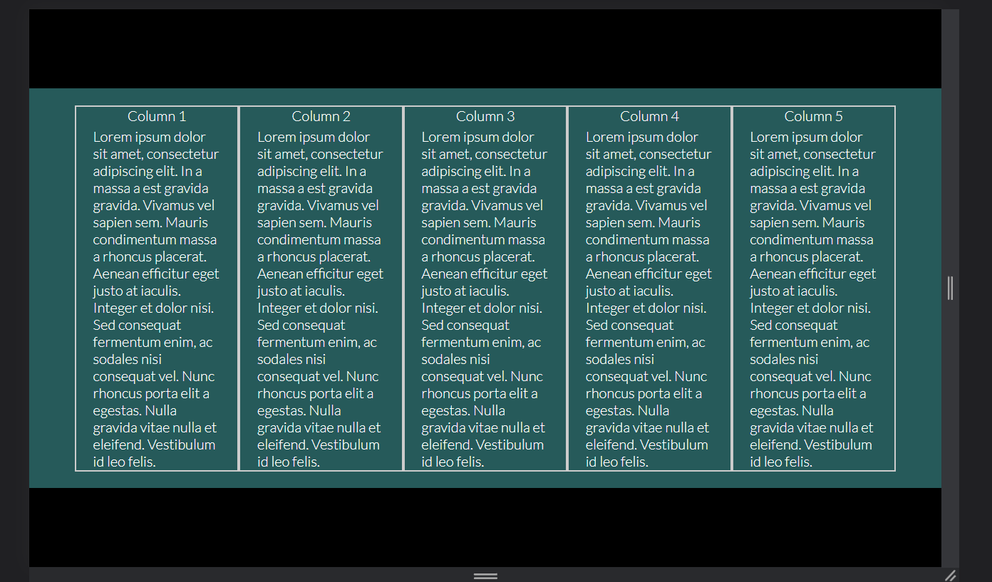

**CONCLUSION:**

Through this experiment, five columns of same size were made with the help of flexbox, which will further help in layout.

**EXPERIMENT - 6**

**AIM:**

Write a HTML code for making table to containing different option for different questions:

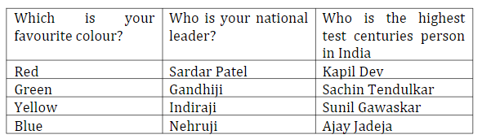

**THEORY:**

**Table Tag**

The <table> tag defines an HTML table. An HTML table consists of one <table> element and one or more <tr>, <th>, and <td> elements. The <tr> element defines a table row, the <th> element defines a table header, and the <td> element defines a table cell. An HTML table may also include <caption>, <colgroup>, <thead>, <tfoot>, and <tbody> elements.

**CODE:**

**HTML:**

<!DOCTYPE html>

<html lang="en">

<head>

<meta charset="UTF-8">

<meta name="viewport" content="width=device-width, initial-scale=1.0">

<link rel="stylesheet" type="text/css" href="./style.css">

<link href="https://fonts.googleapis.com/css2?family=Lato:wght@100;300&display=swap" rel="stylesheet">

<title>Multiple Choices</title>

</head>

<body>

<table>

<tr>

<th>

Which is your favourite colour?

</th>

<th>

Who is your national leader?

</th>

<th>

Who has the highest test centuries in India?

</th>

</tr>

<tr>

<td>

Red

</td>

<td>

Sardar Patel

</td>

<td>

Kapil Dev

</td>

</tr>

<tr>

<td>

Green

</td>

<td>

Gandhiji

</td>

<td>

Sachin Tendulkar

</td>

</tr>

<tr>

<td>

Yellow

</td>

<td>

Indiraji

</td>

<td>

Sunil Gawaskar

</td>

</tr>

<tr>

<td>

Blue

</td>

<td>

Nehruji

</td>

<td>

Ajay Jadeja

</td>

</tr>

</table>

</body>

</html>

**CSS:**

* {

margin: 0;

padding: 0;

font-family: 'Lato', Arial, Helvetica, sans-serif;

color: #fff;

font-size: 20px;

}

html {

height: 100vh;

}

body {

background-color: #121212;

height: 100%;

display: flex;

flex: 1;

justify-content: center;

align-items: center;

}

table {

border: 2px solid #fff;

padding: 10px;

}

td, th {

padding: 10px;

}

tr:nth-child(even) {

background-color: #2c2c2c;

}

tr {

background-color: #3d3d3d;

}

**OUTPUT:**

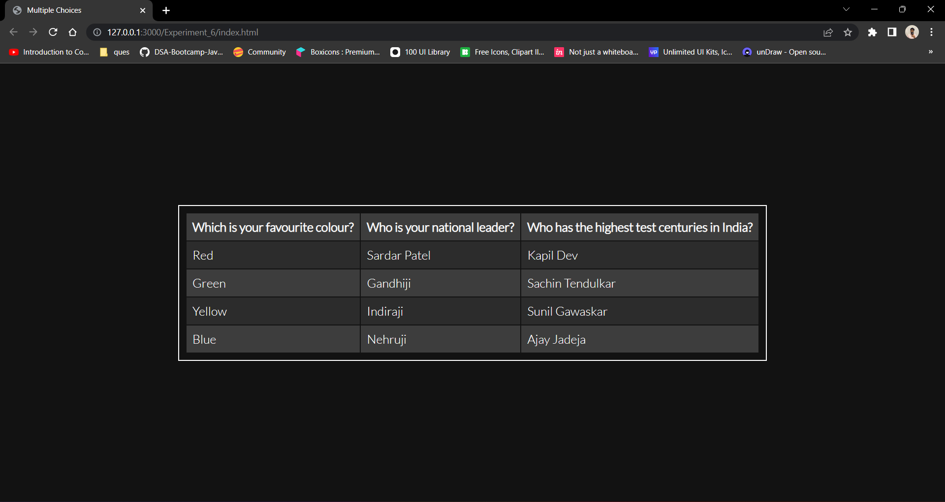

**CONCLUSION:**

Through this experiment, table tag, along with its CSS properties were understood.

**EXPERIMENT - 7**

**AIM:**

Write the Frameset tags and Frame tags for the following frameset:

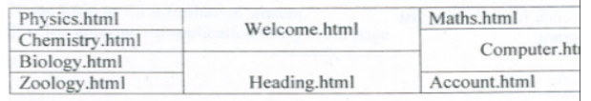

**THEORY:**

**Frameset Tags and Frame Tags**

The <frameset> tag was used in HTML 4 to define a frameset.

Depleted from HTML 5

Instead of frame tag, we have used iframe

**Iframe Tag**

The <iframe> tag specifies an inline frame.

An inline frame is used to embed another document within the current HTML document.

**CODE:**

**HTML:** .

<!DOCTYPE html>

<html lang="en">

<head>

<meta charset="UTF-8">

<meta name="viewport" content="width=device-width, initial-scale=1.0">

<title>Frameset</title>

<link rel="stylesheet" type="text/css" href="./style.css">

<link href="https://fonts.googleapis.com/css2?family=Lato:wght@100;300&display=swap" rel="stylesheet">

</head>

<body>

<div class="container">

<div class="first">

<div class="row">

<iframe src="./physics.html"></iframe>

</div>

<div class="row">

<iframe src="./chemistry.html"></iframe>

</div>

<div class="row">

<iframe src="./biology.html"></iframe>

</div>

<div class="row">

<iframe src="./zoology.html"></iframe>

</div>

</div>

<div class="second">

<div class="row">

<iframe src="./welcome.html"></iframe>

</div>

<div class="row">

<iframe src="./heading.html"></iframe>

</div>

</div>

<div class="third">

<div class="row1">

<iframe src="./maths.html"></iframe>

</div>

<div class="row2">

<iframe src="./computer.html"></iframe>

</div>

<div class="row3">

<iframe src="./account.html"></iframe>

</div>

</div>

</div>

</body>

</html>

**CSS:**

* {

margin: 0;

padding: 0;

font-family: 'Lato', Arial, Helvetica, sans-serif;

color: #fff;

font-size: 20px;

}

html {

height: 100vh;

}

body {

background-color: #121212;

height: 100%;

display: flex;

flex: 1;

justify-content: center;

align-items: center;

}

.container {

width: 1000px;

display: flex;

flex-direction: row;

}

.first, .second, .third {

display: flex;

flex: 1;

flex-direction: column;

}

.row, .row1, .row2, .row3 {

display: flex;

flex: 1;

padding: 2px;

}

.row2 {

flex: 2;

}

iframe {

width: 100%;

padding: 5px;

border: 2px solid white;

}

**OUTPUT:**

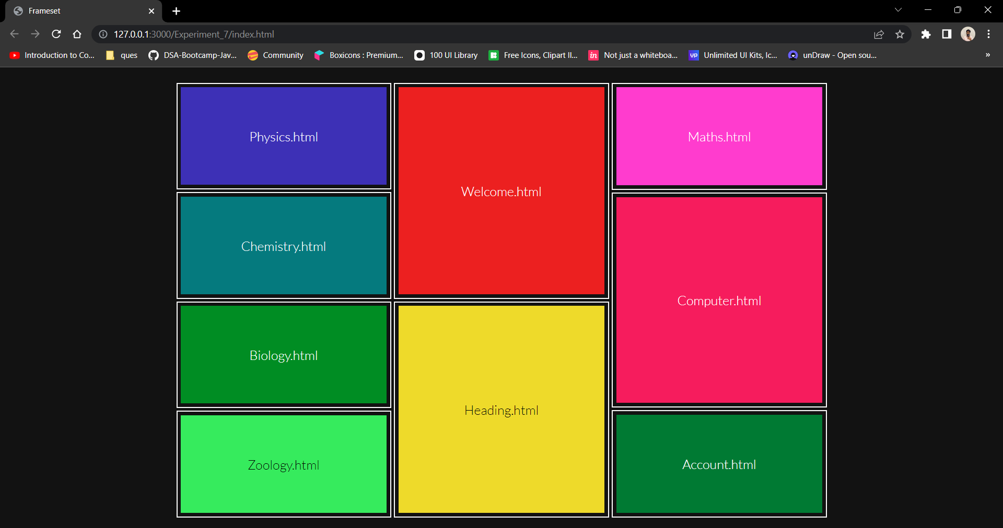

**CONCLUSION:**

Through this experiment, iframe tag and use of iframe tag was understood.

**EXPERIMENT - 8**

**AIM:**

Write html code to generate following output:

 • Coffee

 • Tea

       o Black Tea

       o Green Tea

 • Milk

**THEORY:**

**List Tag**

HTML Lists are used to specify lists of information. All lists may contain one or more list elements. There are three different types of HTML lists:

1. Ordered List or Numbered List (OL)
2. Unordered List or Bulleted List (UL)
3. Description List or Definition List (DL)

# Ordered List or Numbered List

In the ordered HTML lists, all the list items are marked with numbers by default. It is known as numbered list also. The ordered list starts with <ol> tag and the list items start with <li> tag.

# Unordered List or Bulleted List

In HTML Unordered list, all the list items are marked with bullets. It is also known as bulleted list also. The Unordered list starts with <ul> tag and list items start with the <li> tag.

# Description List or Definition List

HTML Description list is also a list style which is supported by HTML and XHTML. It is also known as definition list where entries are listed like a dictionary or encyclopaedia. The HTML definition list contains following three tags:

1. **<dl> tag** defines the start of the list.
2. **<dt> tag** defines a term.
3. **<dd> tag** defines the term definition (description).

**CODE:**

**HTML:**

<!DOCTYPE html>

<html>

<body>

<ul>

<li>Coffee</li>

<li>Tea</li>

<ul>

<li>Black Tee</li>

<li>Green Tee</li>

</ul>

<li>Milk</li>

</ul>

</body>

</html>

**OUTPUT:**

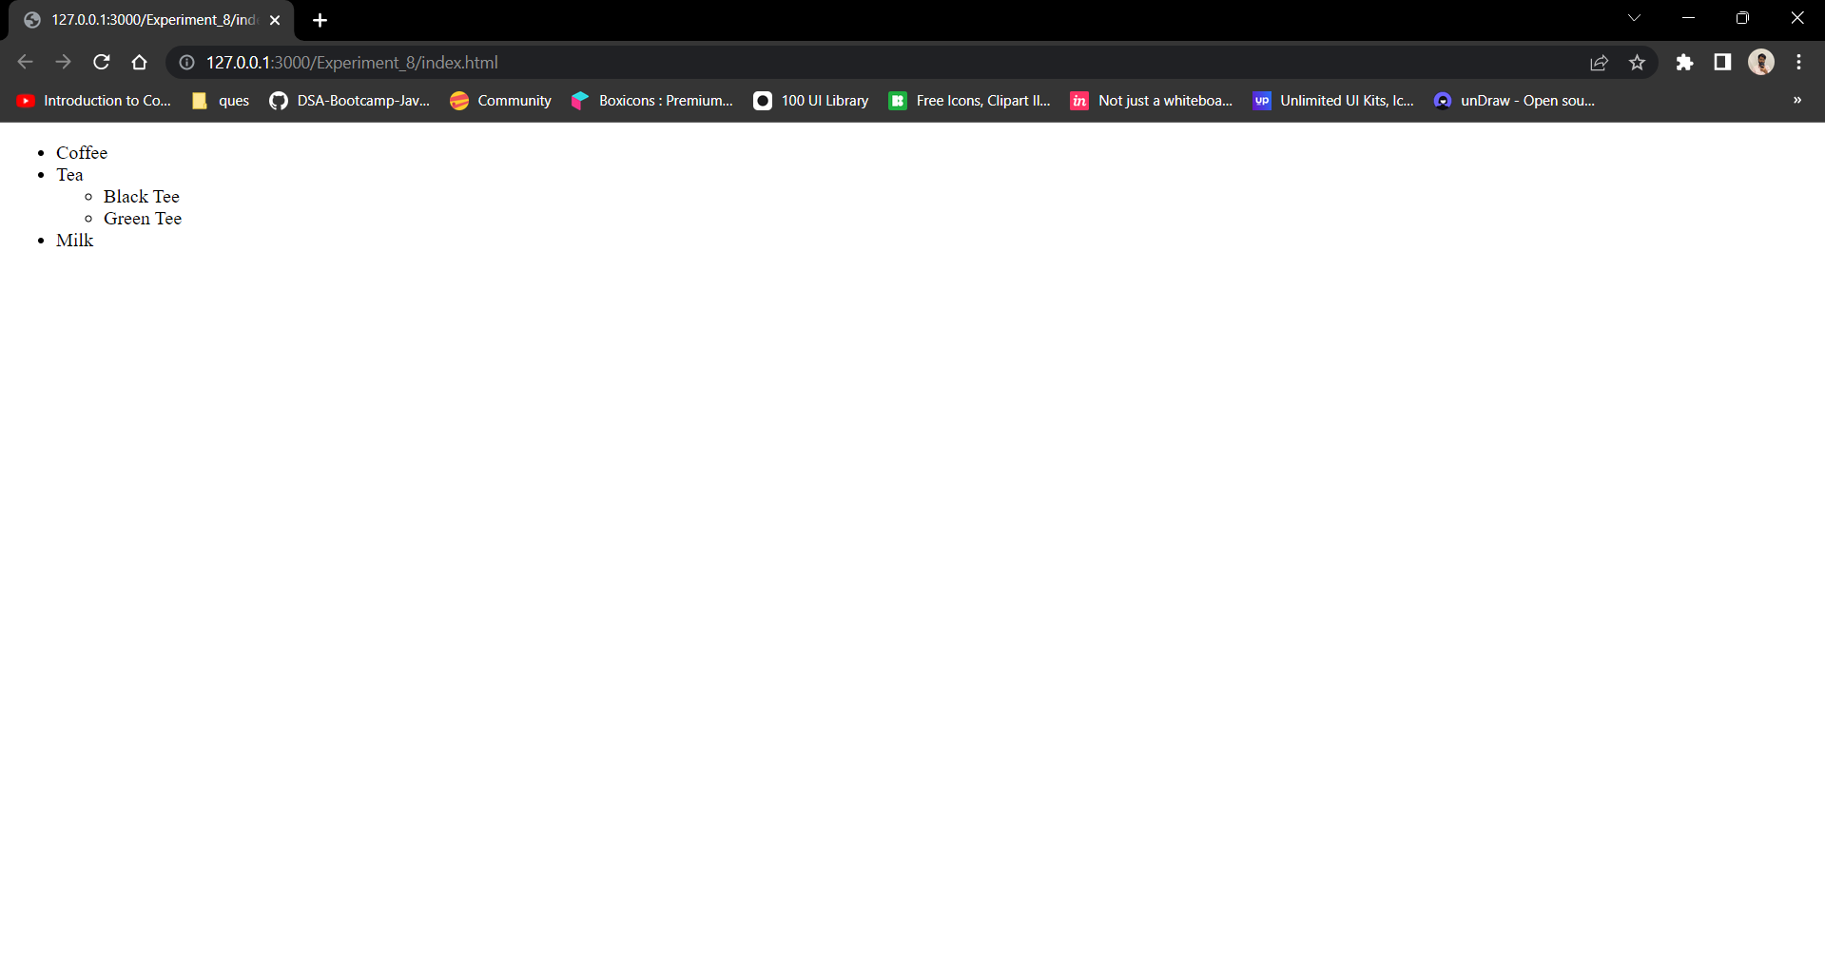

**CONCLUSION:**

Through this experiment, Unordered list tags were understood.

**EXPERIMENT - 9**

**AIM:**

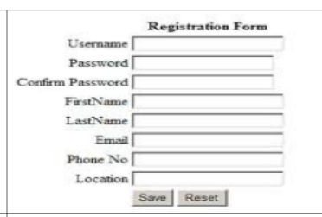Write a HTML code to generate following output:

**THEORY:**

**Form Tag**

The <form> tag is used to create an HTML form for user input.The <form> element can contain one or more of the following form elements:

<input>, <textarea>, <button>, <select>, <option>, <optgroup>, <fieldset> and much more.

**CODE:**

**HTML:**

<!DOCTYPE html>

<html>

<head>

<link rel="stylesheet" href="./style.css">

</head>

<body>

<div class="container">

<div class="row">

<h2>Registration Form</h2>

</div>

<div class="row">

<form action="#">

<div class="row">

<div class="column">

<label for="username">Username</label>

</div>

<div class="column">

<input type="text" id="username" name="username">

</div>

</div>

<div class="row">

<div class="column">

<label for="password">Password</label>

</div>

<div class="column">

<input type="text" id="password" name="password">

</div>

</div>

<div class="row">

<div class="column">

<label for="confirmpas">Confirm Password</label>

</div>

<div class="column">

<input type="text" id="confirmpas" name="confirmpas">

</div>

</div>

<div class="row">

<div class="column">

<label for="fname">FirstName</label>

</div>

<div class="column">

<input type="text" id="fname" name="fname">

</div>

</div>

<div class="row">

<div class="column">

<label for="lname">LastName</label>

</div>

<div class="column">

<input type="text" id="lname" name="lname">

</div>

</div>

<div class="row">

<div class="column">

<label for="email">Email</label>

</div>

<div class="column">

<input type="text" id="email" name="email">

</div>

</div>

<div class="row">

<div class="column">

<label for="phone">Phone</label>

</div>

<div class="column">

<input type="text" id="phone" name="phone">

</div>

</div>

<div class="row">

<div class="column">

<label for="location">Location</label>

</div>

<div class="column">

<input type="text" id="location" name="location">

</div>

</div>

<div class="row">

<div class="column">

<input type="submit" value="Save">

</div>

<div class="column">

<input type="reset" value="Reset">

</div>

</div>

</form>

</div>

</div>

</body>

</html>

**CSS:**

* {

margin: 0;

padding: 0;

font-family: Arial, Helvetica, sans-serif;

}

body {

background-color: #333333;

color: #fff;

}

.container {

display: flex;

flex: 1;

flex-direction: column;

}

.row {

flex: 1;

display: flex;

flex-direction: row;

justify-content: center;

align-items: center;

padding: 5px;

}

.column {

flex: 1;

padding: 5px;

display: flex;

flex-direction: column;

justify-content: center;

align-items: center;

}

**OUTPUT:**

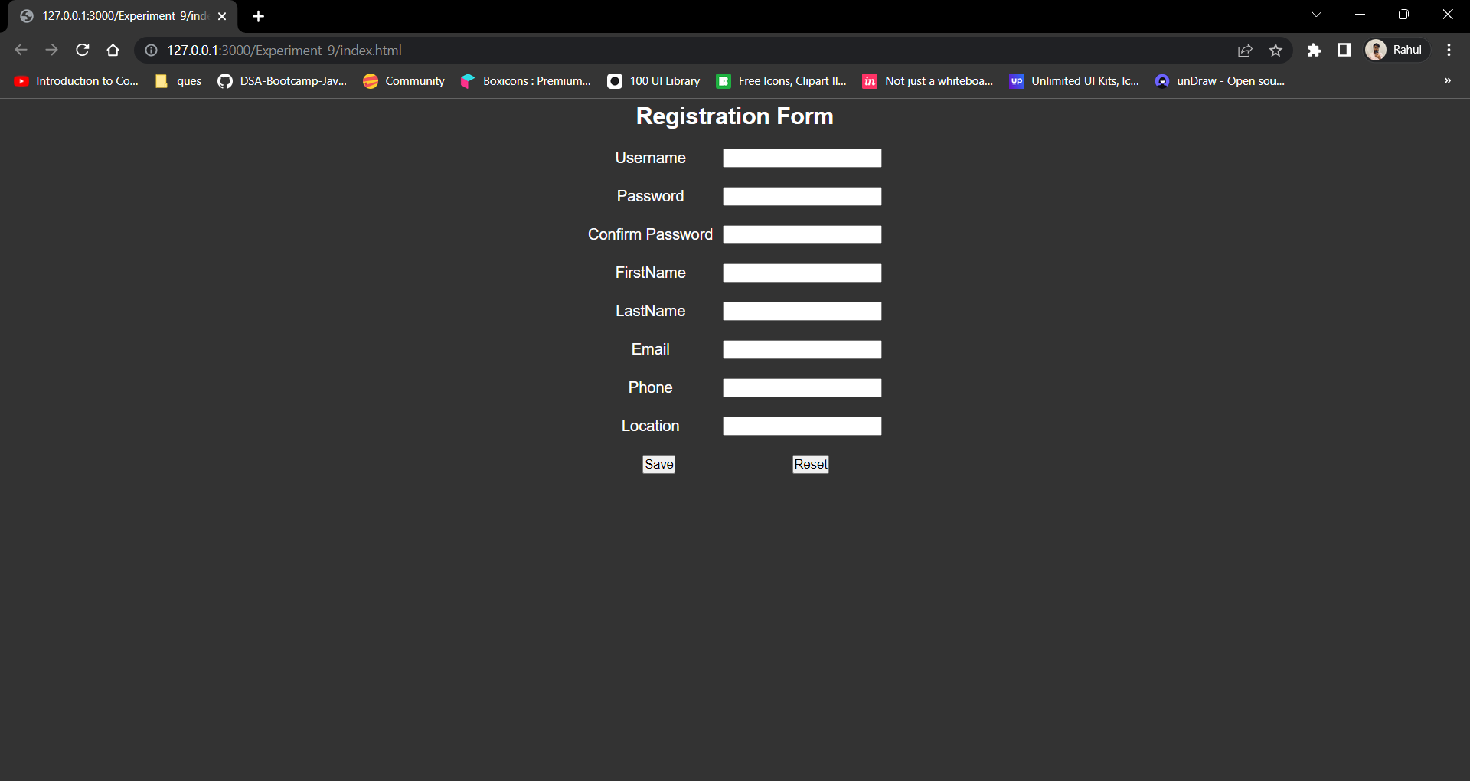

**CONCLUSION:**

Through this experiment, Process of creating a registration form was understood, was developed too.

**EXPERIMENT - 10**

**AIM:**

Write a HTML code to generate following output:

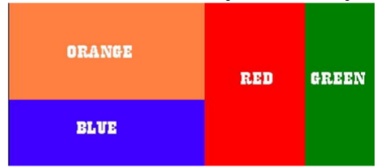

**THEORY:**

**Flexbox-CSS 1-D Layout**

The Flexible Box Module, usually referred to as flexbox, was designed as a one-dimensional layout model, and as a method that could offer space distribution between items in an interface and powerful alignment capabilities.

**Main and cross axis:**

The main axis is defined by flex-direction, which has four possible values:

1. row
2. row-reverse
3. column
4. column-reverse

The cross axis runs perpendicular to the main axis, therefore if your flex-direction (main axis) is set to row or row-reverse the cross axis runs down the columns.

**CODE:**

**HTML:**

<!DOCTYPE html>

<html lang="en">

<head>

<meta charset="UTF-8">

<meta name="viewport" content="width=device-width, initial-scale=1.0">

<title>Blocks</title>

<link rel="stylesheet" type="text/css" href="./style.css">

<link href="https://fonts.googleapis.com/css2?family=Lato:wght@100;300;400&display=swap" rel="stylesheet">

</head>

<body>

<div class="container">

<div class="col1">

<div class="row1">

Orange

</div>

<div class="row2">

Blue

</div>

</div>

<div class="col2">

<div class="row3">

Red

</div>

<div class="row4">

Green

</div>

</div>

</div>

</body>

</html>

**CSS:**

* {

margin : 0;

padding: 0;

text-rendering: optimizeLegibility;

font-family: 'Lato', sans-serif;

}

body {

display: flex;

height: 100vh;

flex-direction: column;

justify-content: space-evenly;

align-items: center;

margin: 0 20%;

background-color: #2c2c2c;

color: rgb(255, 255, 255);

font-size: 25px;

text-transform: uppercase;

}

.container {

display: flex;

width: 1000px;

height: 500px;

flex-direction: row;

}

.col1, .col2 {

display: flex;

flex: 1;

}

.col1 {

flex-direction: column;

}

.col2 {

flex-direction: row;

}

.row1, .row2, .row3, .row4 {

display: flex;

flex: 1;

flex-direction: column;

justify-content: center;

align-items: center;

}

.row1 {

background-color: orange;

}

.row2 {

background-color: blue;

}

.row3 {

background-color: red;

}

.row4 {

background-color: green;

}

**OUTPUT:**

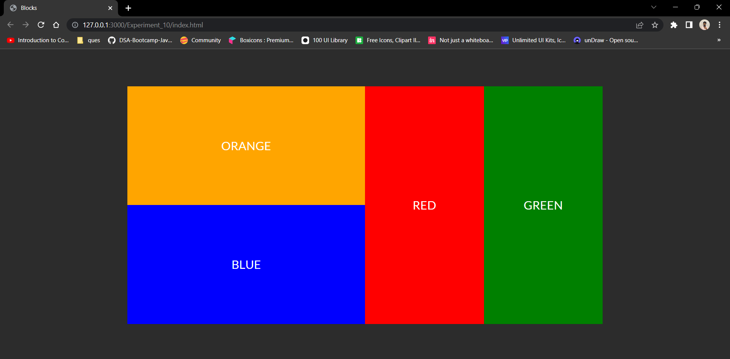

**CONCLUSION:**

Through this experiment, Flexbox was understood and some layouting techniques as well.

**EXPERIMENT - 11**

**AIM:**

Create a web page of your college with following specifications. Place your college name at the top of the page in large text followed by address in smaller size. Add names of courses offered each in a different colour, style, and typeface.

**CODE:**

**HTML:**

<!DOCTYPE html>

<div lang="en">

<head>

<meta charset="UTF-8">

<meta name="viewport" content="width=device-width, initial-scale=1.0">

<link rel="stylesheet" type="text/css" href="./main.css">

<link href="https://fonts.googleapis.com/css2?family=Lato:wght@100;300&display=swap" rel="stylesheet">

<title>Delhi Technological University</title>

</head>

<body>

<div>

<div id="cover">

<img src="./res/img/dtu-logo.png" />

<p>

Delhi Technological University

</p>

<h2>( Formerly Delhi College of Engineering )</h2>

<h4>Shahbad Daulatpur,<br />

Main Bawana Road,<br />

Delhi-110042.<br />

India</h4>

</div>

</div>

<div class="about">

<div class="container">

<div class="text">

<h2>

About Delhi Technological University

</h2>

<p>

"75 years of Tradition of excellence in Engineering & Technology Education, Research and

Innovations" Delhi College of Engineering, (initially established with the name – Delhi

Polytechnic) came into existence in the year 1941 to cater the needs of Indian industries for trained technical manpower with practical experience and sound theoretical knowledge. The institution was set up at historic Kashmere Gate campus as a follow up of the Wood and Abott Committee of 1938. It comprised of a multi disciplinary and multi level institution offering wide ranging programmes in engineering, technology, arts and sculpture, architecture, pharmacy and commerce.

</p>

</div>

<div class="image">

<img src="./res/img/dtu-gate.jpeg" alt="The Image can't be displayed" title="DTU Entrance">

</div>

</div>

</div>

<div class="campus">

<div class="container">

<div class="image">

<img src="./res/img/dsm.png" alt="The Image can't be displayed" title="Indian History">

</div>

<div class="text">

<h2>

Campus

</h2>

<p>

DTU has 164 acres of a lush gree, tech-savvy main campus, with approximately 1,56,000 square metres of built up area, 15 academic departments, research centres, and residences for students, faculty and staff. It is a zero discharge campus having Sewage Treatment Plant and Waste to Energy Plant in the campus itself. The University, as on date, has 11,019 students in its undergraduate, postgraduate and Ph.D programs.

</p>

</div>

</div>

</div>

<div class="courses">

<div class="container">

<div class="courses-header">

<h2>Courses Offered</h2>

</div>

<div class="courses-body">

<div class="course">

<div class="image">

<img src="./res/img/btech.jpg" alt="The Image can't be displayed" title="Indian History">

</div>

<div class="caption">

<h3>B.Tech</h3>

</div>

<div class="text">

<p>

B.Tech is a professional four years undergraduate degree programme in technology

awarded to candidates after completion of the school study. The college offers B.Tech in

15 departments

</p>

</div>

</div>

<div class="course">

<div class="image">

<img src="./res/img/mtech.webp" alt="The Image can't be displayed" title="Indian History">

</div>

<div class="caption">

<h3>M.Tech</h3>

</div>

<div class="text">

<p>

M.Tech is a professional two years postgraduate master degree programme in technology awarded to candidates after completion of two years of study in the discipline of engineering /technology.

</p>

</div>

</div>

<div class="course">

<div class="image">

<img src="./res/img/phd2.jpeg" alt="The Image can't be displayed" title="Indian History">

</div>

<div class="caption">

<h3>Ph.D</h3>

</div>

<div class="text">

<p>

The University offers Ph.D. programme in wide range of areas in Engineering, Sciences

and Humanities. The academic programme of Ph.D. degree is broad-based and

involves a course credit requirement.

</p>

</div>

</div>

<div class="course">

<div class="image">

<img src="./res/img/bdes.jpg" alt="The Image can't be displayed" title="Indian History">

</div>

<div class="caption">

<h3>B.Des</h3>

</div>

<div class="text">

<p>

DTU has decided to provide facilities for excellent design education and training to suit the needs of the society. Department of Design is envisioned to pursue excellence in design thinking, scholarship and practice.

</p>

</div>

</div>

</div>

</div>

</div>

</body>

**CSS:**

* {

margin: 0;

padding: 0;

font-family: 'Lato', Arial, Helvetica, sans-serif;

}

body {

display: flex;

flex-direction: column;

flex: 1;

background-color: #381407;

}

#cover {

display: flex;

flex-direction: column;

height: 100vh;

justify-content: center;

align-items: flex-start;

background :linear-gradient(0deg, rgba(56,20,7,1) 5%, rgba(131, 99, 87, 0.8) 100%), url('../img/IMG_20190409_152154068.jpg');

background-size: cover;

background-position: center;

background-repeat: no-repeat;

}

#cover p, #cover h2, #cover h4 {

margin-left: 50px;

color: rgb(255, 255, 255);

text-transform: uppercase;

}

#cover p {

font-weight: 100;

font-size: 75px;

}

#cover img {

margin-left: 50px;

width: 200px;

}

.container {

color: #fff;

display: flex;

flex-direction: row;

flex-wrap: wrap;

padding: 2% 0;

border-radius: 20px;

margin: 2% 10%;

background: #852907;

}

.campus .container {

background: #9C1300;

}

.text {

flex-wrap: wrap;

display: flex;

flex-direction: column;

justify-content: center;

padding: 0 5%;

flex: 1;

}

.courses .container {

background: #915100;

flex-direction: column;

justify-content: center;

align-items: center;

}

.courses-header {

font-size: 20px;

}

.courses-body {

padding: 2% 0;

display: flex;

flex-direction: row;

justify-content: center;

align-items: center;

}

.courses-body .text p {

font-size: 15px;

}

.courses-body .image {

display: flex;

flex: 1;

padding: 5%;

}

.courses-body .image img {

width: 100%;

}

.course {

flex: 1;

display: flex;

flex-direction: column;

justify-content: center;

align-items: center;

}

.caption {

margin: 1% 0;

}

.text p {

font-size: 20px;

text-align: justify;

}

.image {

flex-wrap: wrap;

flex: 1;

justify-content: center;

align-items: center;

display: flex;

}

.image img {

width: 75%;

border-radius: 20px;

}

.button {

text-decoration: none;

font-size: large;

color: #fff;

background-color: #a03109;

padding: 4% 8%;

border-radius: 50px;

transition: all 0.2s;

}

.button:hover {

background-color: #551c08;

}

#links {

display: flex;

flex-direction: row;

}

.link {

padding: 5% 5%;

flex-direction: row;

justify-content: center;

display: flex;

flex: 1;

}

**OUTPUT:**

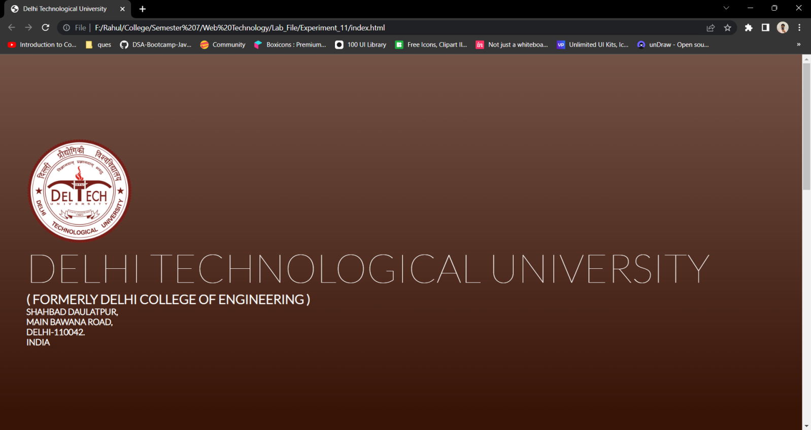

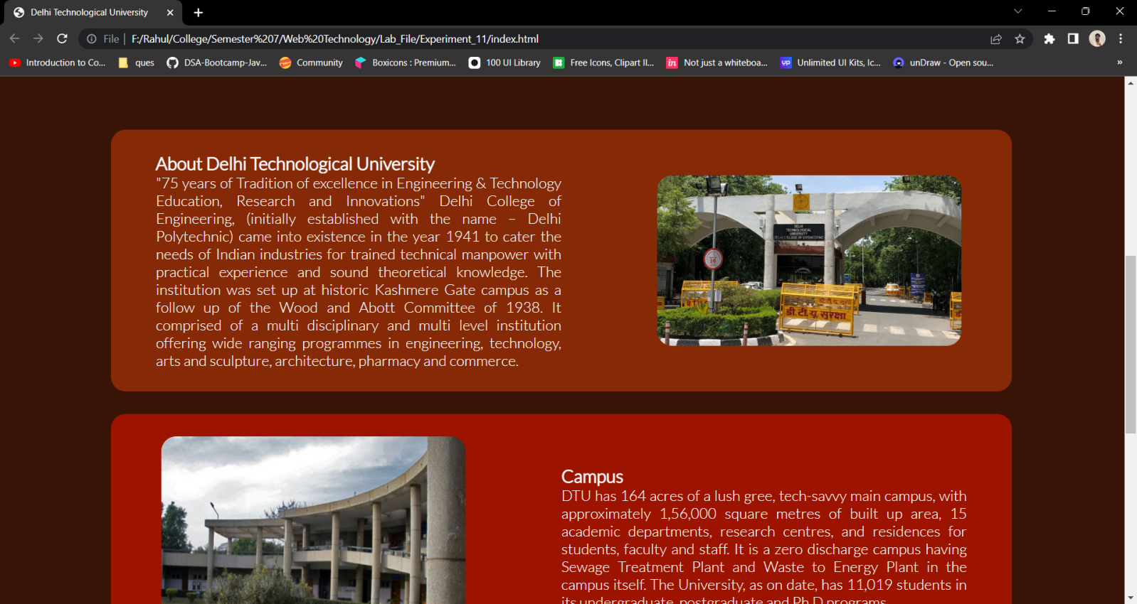

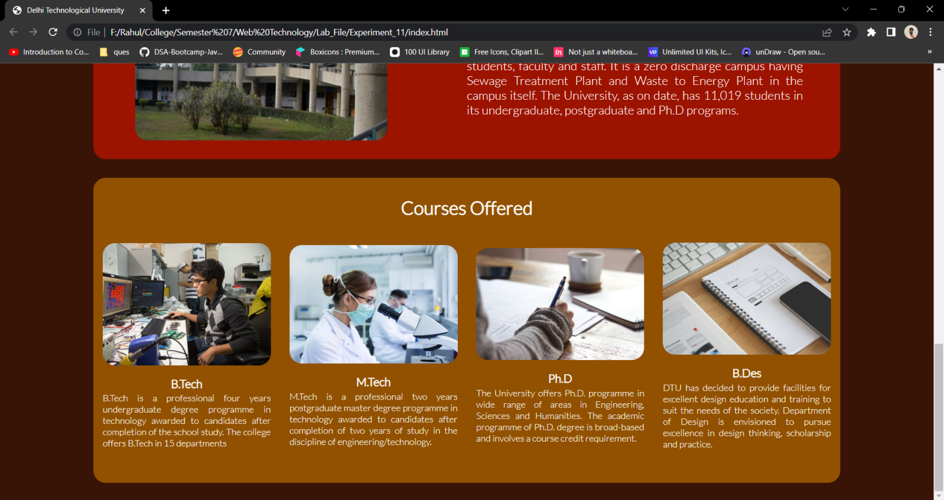

**CONCLUSION:**

Through this experiment, different HTML elements and their attributes and their styles were understood.

**EXPERIMENT - 12**

**AIM:**

Write a HTML code to generate following output:

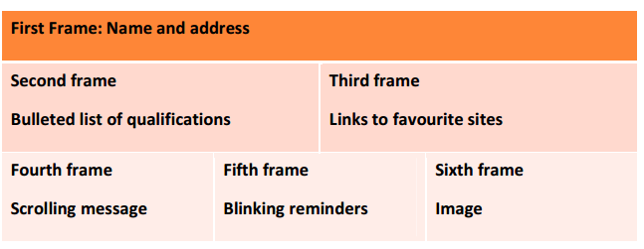

**CODE:**

**HTML:**

<!DOCTYPE html>

<html lang="en">

<head>

<meta charset="UTF-8">

<meta name="viewport" content="width=device-width, initial-scale=1.0">

<title>Frames</title>

<link rel="stylesheet" type="text/css" href="./main.css">

<link href="https://fonts.googleapis.com/css2?family=Lato:wght@100;300;400&display=swap" rel="stylesheet">

</head>

<body>

<div class="container">

<div class="header">

First Frame : Name and address

</div>

<div class="row">

<div class="col">

Second Frame

<br/>

Bulleted list of qualifications

</div>

<div class="col">

Third Frame

<br/>

Links to favourite sites

</div>

</div>

<div class="row">

<div class="col">

Fourth frame

<br/>

Scrolling message

</div>

<div class="col">

Fifth frame

<br/>

Blinking reminders

</div>

<div class="col">

Sixth frame

<br/>

Image

</div>

</div>

</div>

</body>

</html>

**CSS:**

* {

margin : 0;

padding: 0;

text-rendering: optimizeLegibility;

font-family: 'Lato', sans-serif;

}

body {

display: flex;

height: 100vh;

flex-direction: column;

justify-content: space-evenly;

align-items: center;

margin: 0 20%;

background-color: #2c2c2c;

}

.container {

display: flex;

width: 1000px;

height: 250px;

flex-direction: column;

}

.header {

display: flex;

flex: 1;

background-color: orange;

flex-direction: column;

justify-content: center;

padding-left: 5px;

}

.row {

display: flex;

flex: 2;

background-color: rgb(255, 196, 157);

flex-direction: row;

}

.col {

display: flex;

flex: 1;

flex-direction: column;

justify-content: center;

padding-left: 5px;

border: 1px solid white;

}

**OUTPUT:**

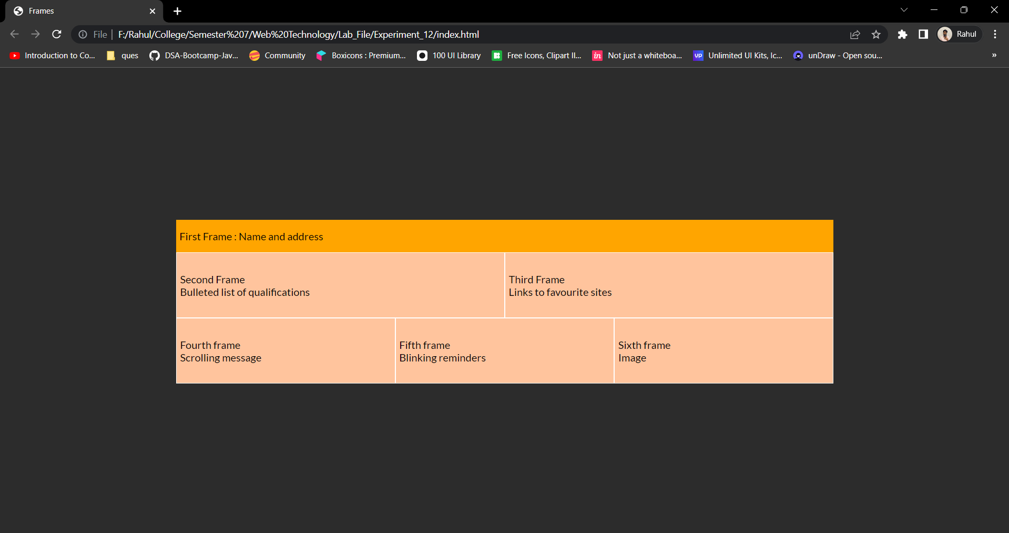

**CONCLUSION:**

Through this experiment, different HTML elements and their attributes and their styles were understood.

**EXPERIMENT - 13**

**AIM:**

Create an html page containing the polynomial expression as follows:

a0 + a1x+ a2x 2 + a3 x3

**THEORY:**

**SUP tag**

The <sup> tag defines superscript text. Superscript text appears half a character above the normal line, and is sometimes rendered in a smaller font.

**SUB tag**

The <sub> tag defines subscript text. Subscript text appears half a character below the normal line, and is sometimes rendered in a smaller font.

**CODE:**

**HTML:**

<!DOCTYPE html>

<html lang="en">

<head>

<meta charset="UTF-8">

<meta name="viewport" content="width=device-width, initial-scale=1.0">

<title>Subscript</title>

<link rel="stylesheet" type="text/css" href="./main.css">

<link href="https://fonts.googleapis.com/css2?family=Lato:wght@100;300;400&display=swap" rel="stylesheet">

</head>

<body>

<div class="container">

<h1>

a<sub>0</sub>+a<sub>1</sub>x+a<sub>2</sub>x<sup>2</sup>+a<sub>3</sub>x<sup>3</sup>

</h1>

</div>

</body>

</html>

**CSS:**

* {

margin : 0;

padding: 0;

text-rendering: optimizeLegibility;

font-family: 'Lato', sans-serif;

}

body {

display: flex;

height: 100vh;

flex-direction: column;

justify-content: space-evenly;

align-items: center;

margin: 0 20%;

background-color: #2c2c2c;

color: #ffffff;

}

.container {

display: flex;

width: 1000px;

height: 250px;

flex-direction: column;

align-items: center;

justify-content: center;

}

sub, sup {

font-size: 20px;

}

**OUTPUT:**

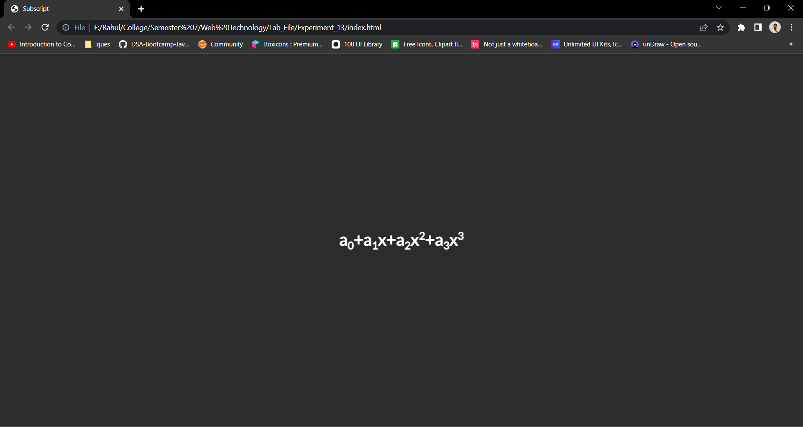

**CONCLUSION:**

Through this experiment, different HTML elements and their attributes and their styles were understood.

**EXPERIMENT - 14**

**AIM:**

Write a HTML code to generate following output:

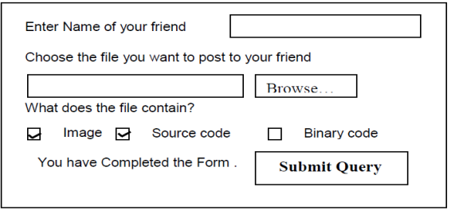

**CODE:**

**HTML:**

<!DOCTYPE html>

<html lang="en">

<head>

<meta charset="UTF-8">

<meta name="viewport" content="width=device-width, initial-scale=1.0">

<title>Form</title>

<link rel="stylesheet" type="text/css" href="./main.css">

<link href="https://fonts.googleapis.com/css2?family=Lato:wght@100;300;400&display=swap" rel="stylesheet">

</head>

<body>

<div class="container">

<form>

<label for="name">Enter Name of your friend</label>

<input type="text" name="name" id="name"/>

<br/>

<label for="file">Choose the file you want to post to your friend</label>

<br/>

<input type="text" name="file" id="file"/>

<button>Browse...</button>

<p>What does this file contain?</p>

<input type="checkbox" id="img"/>

<label for="img">Image</label>

<input type="checkbox" id="sc"/>

<label for="sc">Source code</label>

<input type="checkbox" id="bc"/>

<label for="bc">Binary code</label>

<br/>

<b>You have completed the form</b>

<button>Submit Query</button>

</form>

</div>

</body>

</html>

**CSS:**

* {

margin : 0;

padding: 0;

text-rendering: optimizeLegibility;

font-family: 'Lato', sans-serif;

}

body {

display: flex;

height: 100vh;

flex-direction: column;

justify-content: space-evenly;

align-items: center;

margin: 0 20%;

background-color: #2c2c2c;

color: #ffffff;

}

.container {

display: flex;

width: 1000px;

flex-direction: column;

align-items: center;

justify-content: center;

}

**OUTPUT:**

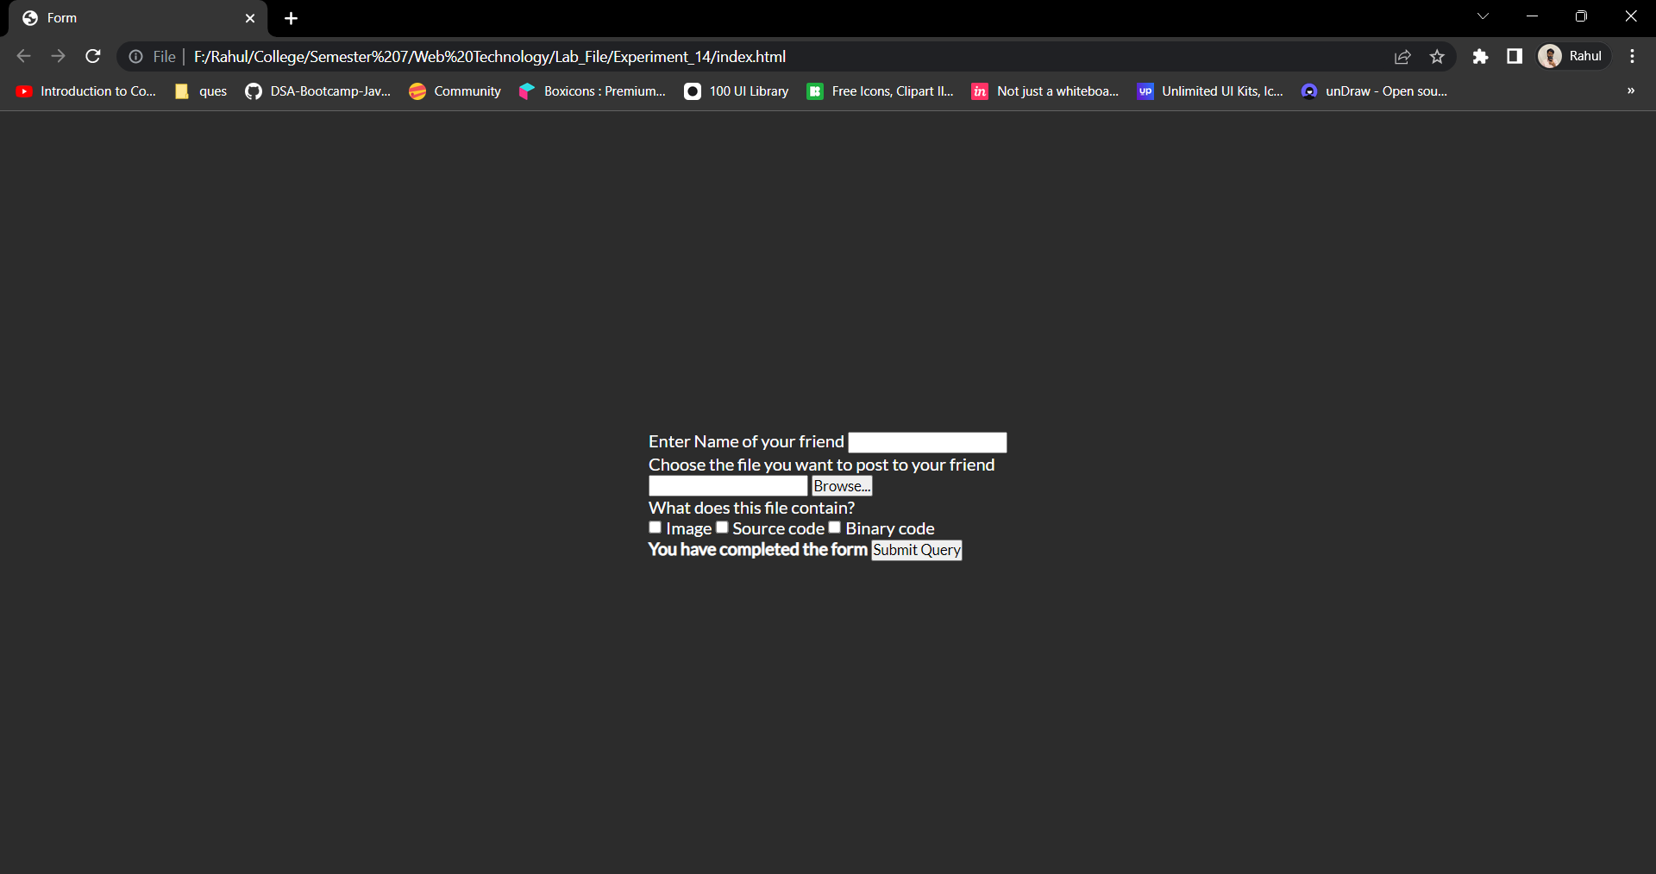

**CONCLUSION:**

Through this experiment, different HTML elements and their attributes and their styles were understood.

**EXPERIMENT - 15**

**AIM:**

Create a simple form to submit user input like his name, age, address and favorite subject. Put validation checks on values entered by the user using JavaScript (such as age should be a value between 1 and 150).

**CODE:**

**HTML:**

<!DOCTYPE html>

<html lang="en">

<head>

<meta charset="UTF-8">

<meta name="viewport" content="width=device-width, initial-scale=1.0">

<title>Form Validation</title>

<link rel="stylesheet" type="text/css" href="./main.css">

<link href="https://fonts.googleapis.com/css2?family=Lato:wght@100;300;400&display=swap" rel="stylesheet">

<script src="./main.js" defer></script>

</head>

<body>

<div id="error"></div>

<form method="GET" id="form">

<div>

<label for="name">Name</label>

<input name="name" id="name">

</div>

<div>

<label for="age">Age</label>

<input name="age" id="age" type="number">

</div>

<div>

<label for="address">Address</label>

<input name="address" id="address" type="text">

</div>

<div>

<label for="favourite-subject">Favourite Subject</label>

<input name="favourite-subject" id="favourite-subject" type="text">

</div>

<button type="submit">Submit</button>

<button type="reset">Reset</button>

</form>

</body>

</html>

**CSS:**

* {

box-sizing: border-box;

margin : 0;

padding: 0;

text-rendering: optimizeLegibility;

font-family: 'Lato', sans-serif;

}

body {

height: 100vh;

display: flex;

flex-direction: column;

justify-content: center;

align-items: center;

margin: 0 20%;

background-color: #121212;

color: #ffffff;

}

form {

padding: 10px;

border-radius: 10px;

background-color: rgb(58, 58, 58);

}

form div {

display: flex;

flex: 1;

justify-content: space-between;

flex-direction: column;

}

input {

outline: none;

border: none;

color: #ffffff;

background-color: rgb(110, 110, 110);

height: 40px;

font-size: 1.2rem;

padding-left: 10px;

padding-right: 10px;

margin: 5px;

border-radius: 10px;

}

label {

font-size: 1.2rem;

padding: 10px;

}

button {

outline: none;

border: none;

padding: 10px;

margin: 5px;

font-size: 1rem;

background-color: #0099ff;

color: #ffffff;

cursor: pointer;

transition: all 0.3s;

border-radius: 10px;

}

button:hover {

background-color: #0086df;

}

#error {

background-color: rgba(255, 0, 0, 0.603);

font-size: 1.1rem;

padding: 10px;

margin: 10px;

border-radius: 10px;

}

**JS:**

const name = document.getElementById('name');

const age = document.getElementById('age');

const address = document.getElementById('address');

const favouriteSubject = document.getElementById('favourite-subject');

const form = document.getElementById('form');

const errorElement = document.getElementById('error');

form.addEventListener('submit', (e) => {

let messages = [];

if (name.value === '' || name.value == null) {

messages.push('Name is required');

}

if (parseFloat(age.value) < 1 || parseFloat(age.value) > 150 || age.value === '') {

messages.push('Age should be between 1 and 150');

}

if (address.value === '' || address.value == null) {

messages.push('Address is required');

}

if (favouriteSubject.value === '' || favouriteSubject.value == null) {

messages.push('Favourite subject is required');

}

if (messages.length > 0) {

e.preventDefault();

errorElement.innerText = messages.join(', ');

}

});

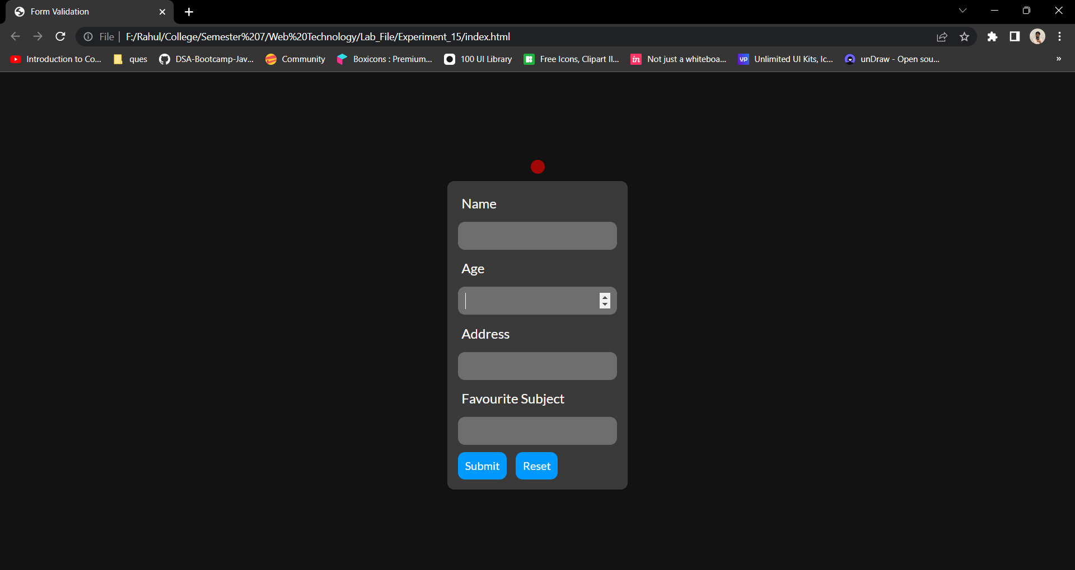**OUTPUT:**

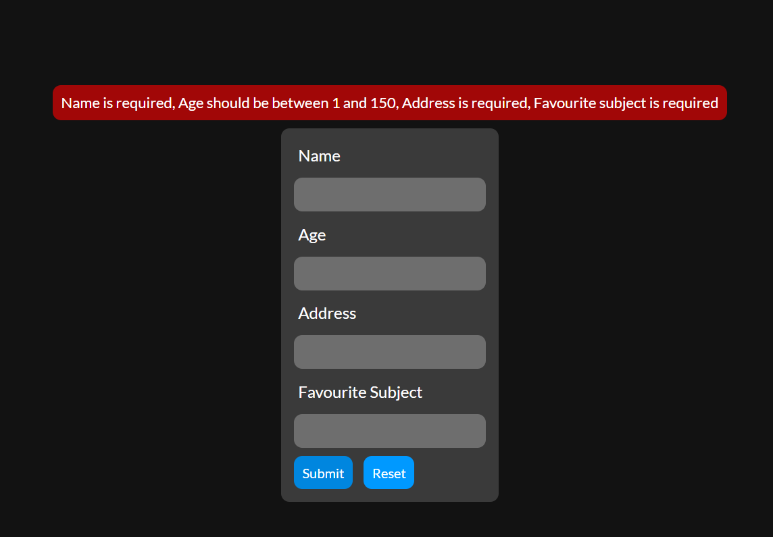

**CONCLUSION:**

Through this experiment, different JavaScript functions were understood.

**EXPERIMENT - 16**

**AIM:**

Write a JavaScript program to display information box as soon as page loads.

**CODE:**

**HTML:**

<!DOCTYPE html>

<html lang="en">

<head>

<meta charset="UTF-8">

<meta name="viewport" content="width=device-width, initial-scale=1.0">

<title>JS Popup</title>

<link rel="stylesheet" href="./main.css">

<script src="./main.js" defer></script>

<link href="https://fonts.googleapis.com/css2?family=Lato:wght@100;300;400&display=swap" rel="stylesheet">

</head>

<body>

<div id="popup">

This is an information box

</div>

</body>

</html>

**CSS:**

* {

box-sizing: border-box;

margin : 0;

padding: 0;

text-rendering: optimizeLegibility;

font-family: 'Lato', sans-serif;

}

body {

background-color: #2c2c2c;

color: #ffffff;

display: flex;

flex: 1;

justify-content: center;

align-items: center;

min-height: 100vh;

}

#popup {

background-color: rgb(47, 136, 209);

padding: 15px;

border-radius: 10px;

display: none;

transition: all 0.3s;

}

**JS:**

const popup = document.getElementById('popup');

window.onload = () => {

setTimeout(() => {

popup.style.display = 'flex';

}, 1000);

}

**OUTPUT:**

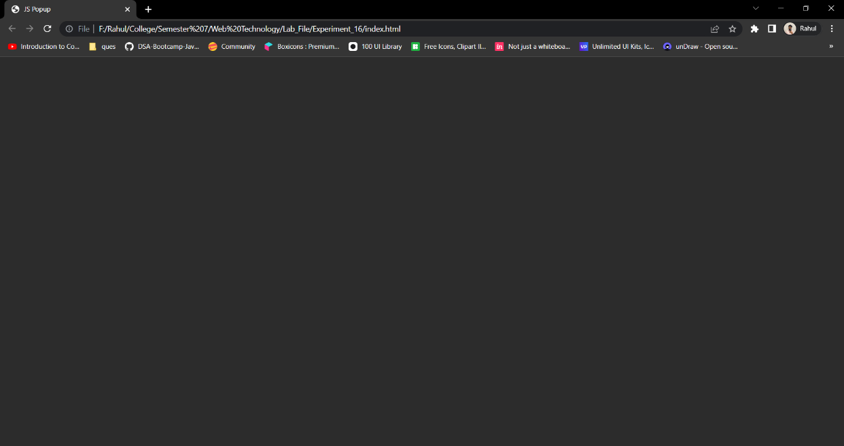

**After 1.5 Seconds**

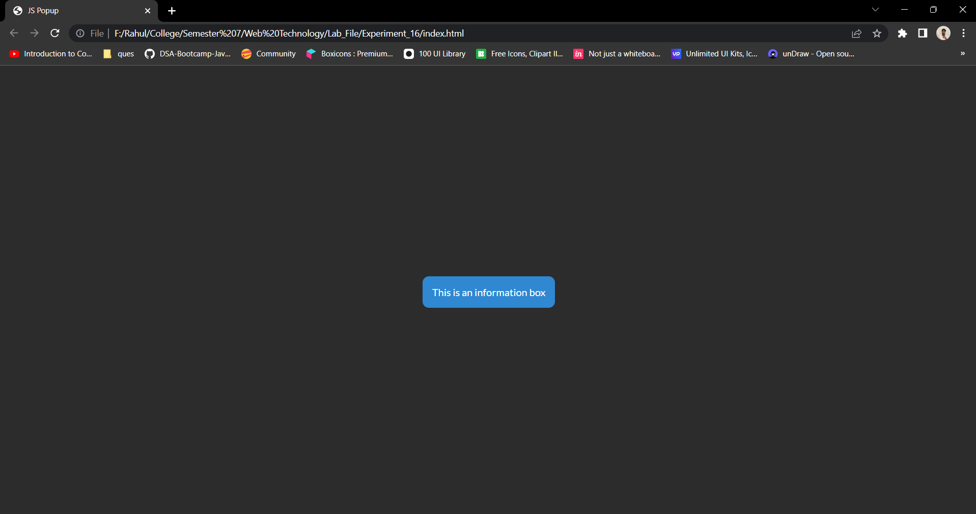

**CONCLUSION:**

Through this experiment, different JavaScript functions were understood.

**EXPERIMENT - 17**

**AIM:**

Write a JavaScript program to change background colour after 5 seconds of page load.

**CODE:**

**HTML:**

<!DOCTYPE html>

<html lang="en">

<head>

<meta charset="UTF-8">

<meta name="viewport" content="width=device-width, initial-scale=1.0">

<title>Background Color Change</title>

<script src="./main.js" defer></script>

</head>

<body>

</body>

</html>

**JS:**

window.onload = () => {

setTimeout(() => {

console.log('Changing background color');

document.body.style.backgroundColor = '#2c2c2c'

}, 5000);

}

**OUTPUT:**

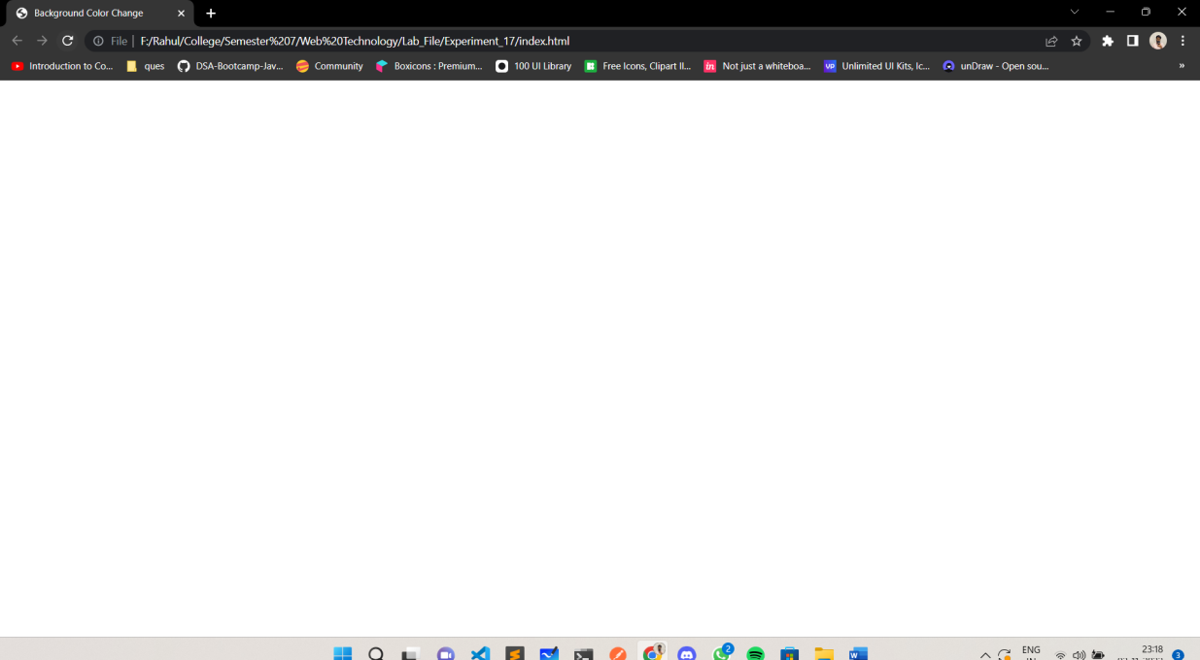

**After 5 Seconds**

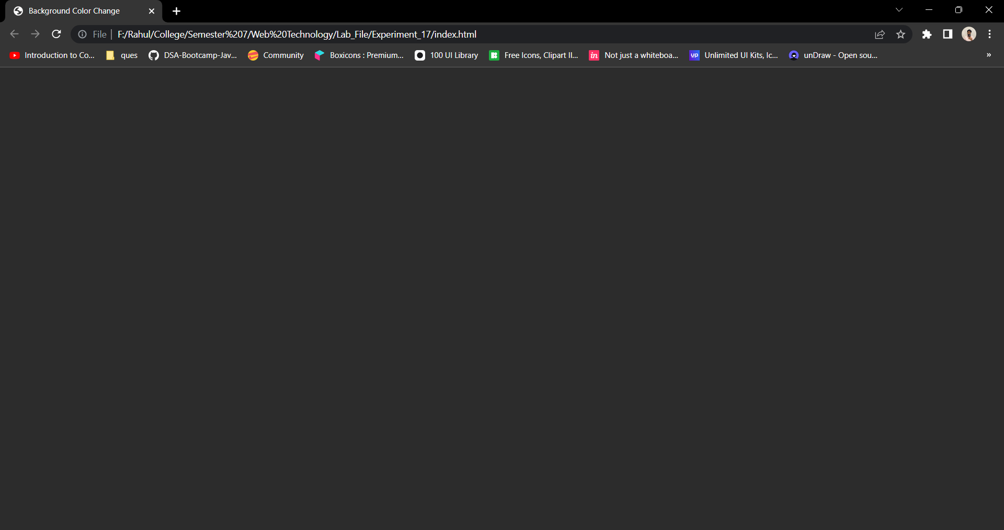

**CONCLUSION:**

Through this experiment, different JavaScript functions were understood.

**EXPERIMENT - 18**

**AIM:**

Write a JavaScript program to dynamically bold, italic and underline words and phrases based on user actions.

**CODE:**

**HTML:**

<!DOCTYPE html>

<html lang="en">

<head>

<meta charset="UTF-8">

<meta name="viewport" content="width=device-width, initial-scale=1.0">

<title>Change Style</title>

<link rel="stylesheet" type="text/css" href="./style.css">

<link href="https://fonts.googleapis.com/css2?family=Lato:wght@100;300;400&display=swap" rel="stylesheet">

<script src="./script.js" defer></script>

</head>

<body>

<div id="container">

<div id="text">

Click the Buttons to change the text style.

<br>

Hover to Bold the text.

</div>

<div>

<button id="myBtn" onclick="italics()">Italics</button>

<button onclick="underlines()">Underline</button>

</div>

</div>

</body>

</html>

**CSS:**

* {

box-sizing: border-box;

margin : 0;

padding: 0;

text-rendering: optimizeLegibility;

font-family: 'Lato', sans-serif;

}

body {

height: 100vh;

display: flex;

flex-direction: column;

justify-content: center;

align-items: center;

margin: 0 20%;

background-color: #9731CE;

color: white;

}

#container {

height: 50vh;

width: 50vw;

display: flex;

flex-direction: column;

justify-content: center;

align-items: center;

text-align: center;

margin: 0 20%;

background-color: #470E65;

color: white;

border-style: solid;

font-size: 30px;

}

button {

height: 5vh;

width: 10vw;

background-color: #44A9C6;

border: none;

border-radius: 8px;

box-shadow: 0 8px 16px 0 rgba(0,0,0,0.2), 0 6px 20px 0 rgba(0,0,0,0.19);

color: white;

text-align: center;

font-size: 18px;

}

**JS:**

const italics = () => {

document.getElementById("text").style.fontStyle = "italic";

}

const underlines = () => {

document.getElementById("text").style.textDecoration = "underline";

}

document.getElementById("text").addEventListener("mouseover", ()=>{

document.getElementById("text").style.fontWeight = "bold";

});

**OUTPUT:**

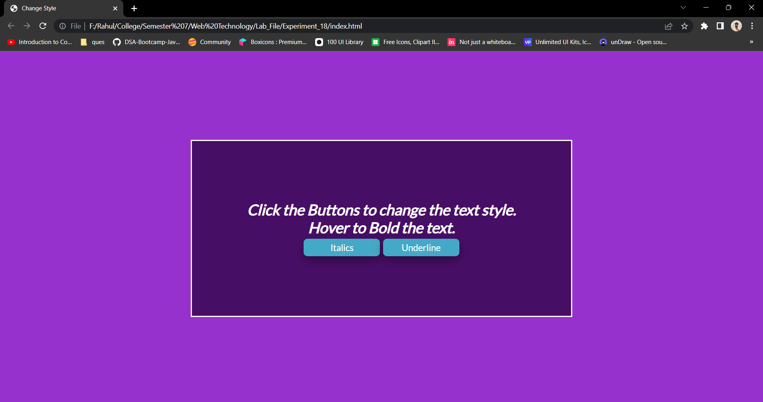

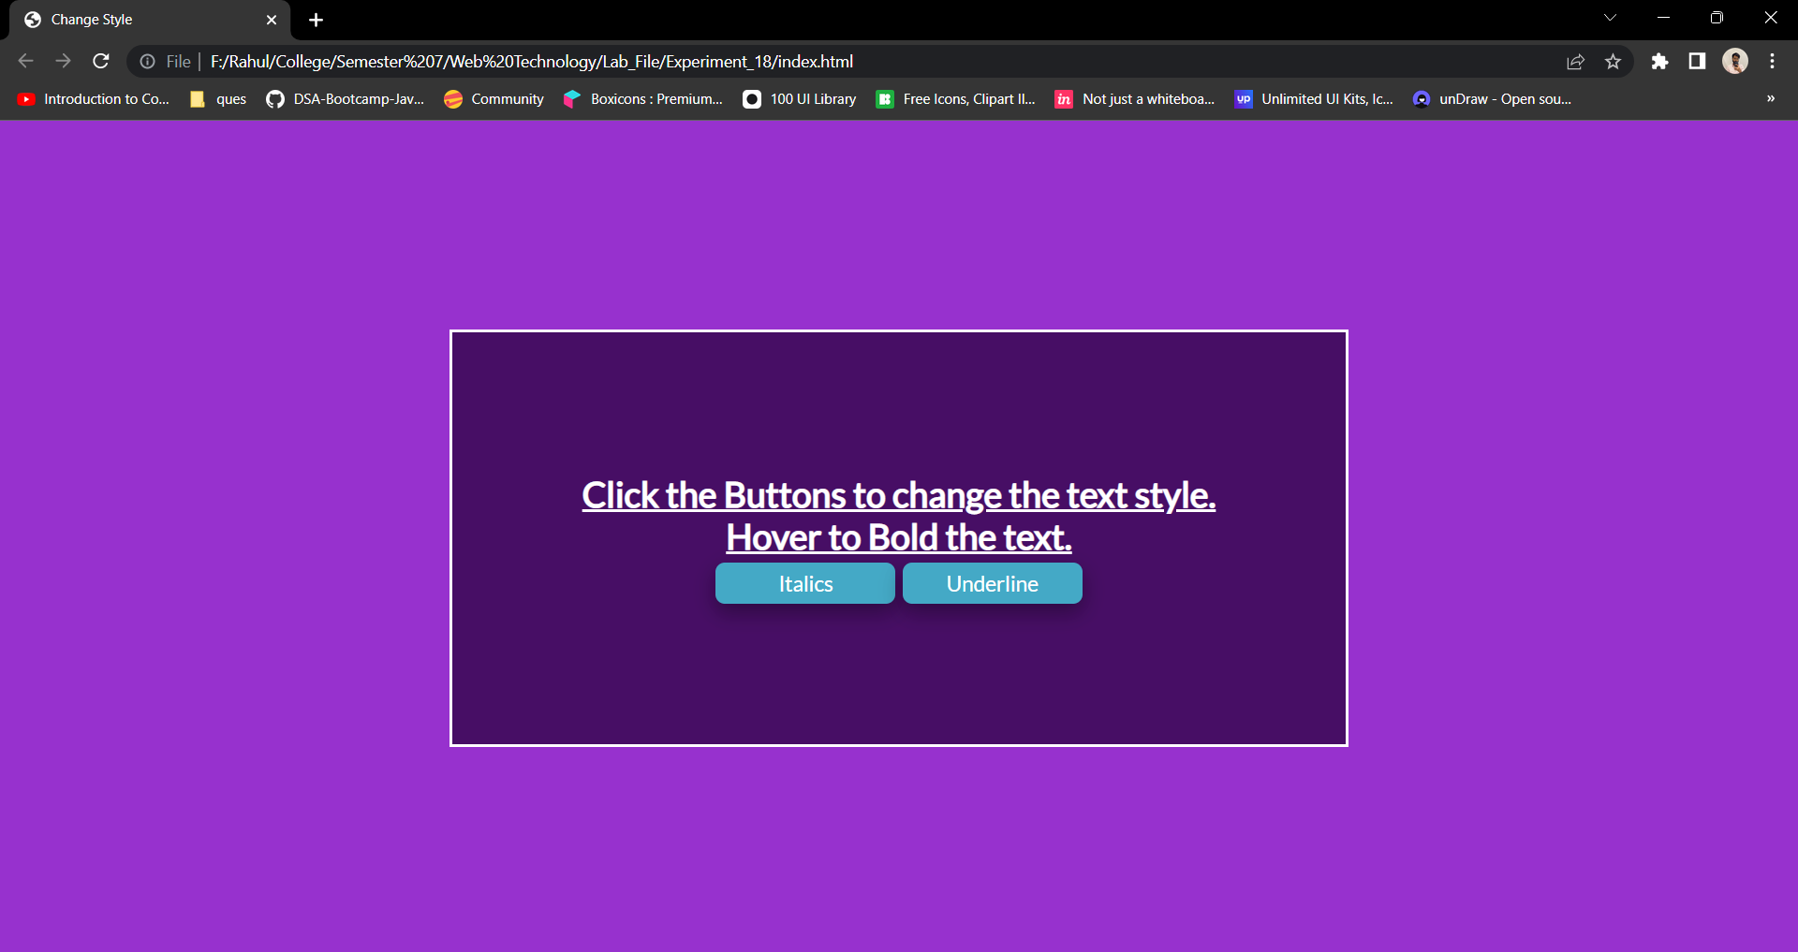

**CONCLUSION:**

Through this experiment, different JavaScript functions were understood.

**EXPERIMENT - 19**

**AIM:**

Write a JavaScript program to display a hidden div (e.g., showing stats of a player when user clicks on his name).

**CODE:**

**HTML:**

<!DOCTYPE html>

<html lang="en">

<head>

<meta charset="UTF-8">

<meta name="viewport" content="width=device-width, initial-scale=1.0">

<title>Stats</title>

<link rel="stylesheet" type="text/css" href="./style.css">

<link href="https://fonts.googleapis.com/css2?family=Lato:wght@100;300;400&display=swap" rel="stylesheet">

<script src="./script.js" defer></script>

</head>

<body>

<div id="container">

<div id="stats">

<div>Ritik</div>

<div id="Ritik">

<br>Roll.No : 2K19/CO/319<br>

Branch : Computer Engineering<br>

Hobby : Game Development<br><br>

</div>

<button id="ritikBtn" onclick="showRitik()">Show Stats</button>

</div>

<div id="stats">

<div>Trav</div>

<div id="Trav">

<br>Roll.No : 2K19/CO/369<br>

Branch : Computer Engineering<br>

Hobby : Competitive Coding<br><br>

</div>

<button id="TravBtn" onclick="showTrv()">Show Stats</button>

</div>

</div>

</body>

</html>

**CSS:**

* {

box-sizing: border-box;

margin : 0;

padding: 0;

text-rendering: optimizeLegibility;

font-family: 'Lato', sans-serif;

}

body {

height: 100vh;

display: flex;

flex-direction: column;

justify-content: center;

align-items: center;

margin: 0 20%;

color: white;

}

#container {

height: 50vh;

width: 50vw;

display: flex;

flex-direction: row;

justify-content: space-evenly;

align-items: center;

text-align: center;

margin: 0 20%;

color: white;

border-style: solid;

font-size: 30px;

}

#Ritik ,#Trav {

font-size: 16px;

text-align: left;

border-style: solid;

padding: 10px;

border-radius: 8px;

}

button {

height: 5vh;

width: 10vw;

background-color: #44A9C6;

border: none;

border-radius: 8px;

box-shadow: 0 8px 16px 0 rgba(0,0,0,0.2), 0 6px 20px 0 rgba(0,0,0,0.19);

text-align: center;

font-size: 18px;

}

**JS:**

document.getElementById("Ritik").style.display = "none";

document.getElementById("Trav").style.display = "none";

const showRitik = () => {

var x = document.getElementById("Ritik");

if (x.style.display === "none") {

x.style.display = "block";

document.getElementById("RitikBtn").innerHTML = "Hide Stats";

} else {

x.style.display = "none";

document.getElementById("RitikBtn").innerHTML = "Show Stats";

} }

const showTrav = () => {

var x = document.getElementById("Trav");

if (x.style.display === "none") {

x.style.display = "block";

document.getElementById("TravBtn").innerHTML = "Hide Stats";

} else {

x.style.display = "none";

document.getElementById("TravBtn").innerHTML = "Show Stats";

}

}

**OUTPUT:**

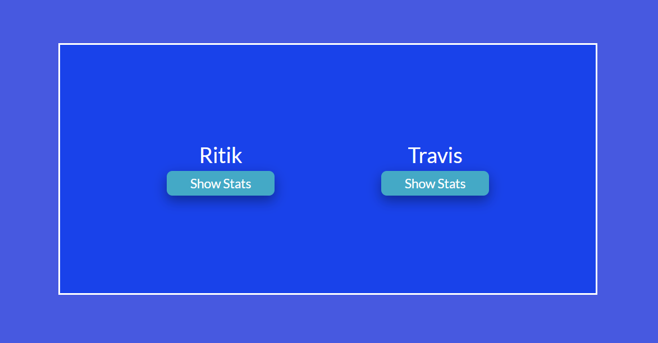

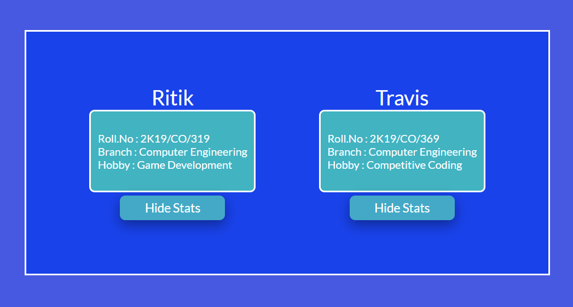

**CONCLUSION:**

Through this experiment, different JavaScript functions were understood.

**EXPERIMENT - 20**

**AIM:**

Write a JavaScript function to check whether an `input` is a string or not and if it is a string, then check if it is blank or not?

**CODE:**

**HTML:**

<!DOCTYPE html>

<html lang="en">

<head>

<meta charset="UTF-8">

<meta name="viewport" content="width=device-width, initial-scale=1.0">

<title>String Check</title>

<link rel="stylesheet" type="text/css" href="./style.css">

<link href="https://fonts.googleapis.com/css2?family=Lato:wght@100;300;400&display=swap" rel="stylesheet">

<script src="./script.js" defer></script>

</head>

<body>

<div id="container">

Input Text Below<br><br>

<input id="text" type="text"><br>

<button onclick="checkString()">Check</button><br>

<div id="result"></div>

</div>

</body>

</html>

**CSS:**

* {

box-sizing: border-box;

margin : 0;

padding: 0;

text-rendering: optimizeLegibility;

font-family: 'Lato', sans-serif;

}

body {

height: 100vh;

display: flex;

flex-direction: column;

justify-content: center;

align-items: center;

margin: 0 20%;

background-color: #9731CE;

color: white;

}

#container {

height: 50vh;

width: 50vw;

display: flex;

flex-direction: column;

justify-content: center;

align-items: center;

text-align: center;

margin: 0 20%;

background-color: #470E65;

color: white;

border-style: solid;

font-size: 30px;

}

#result {

display: none;

font-size: 20px;

border-style: solid;

padding: 10px;

}

input {

height: 5vh;

width: 20vw;

background-color: #BCEAF0;

border: none;

border-radius: 10px;

color: #470E65;

text-align: center;

font-size: 18px;

}

button {

height: 5vh;

width: 10vw;

background-color: #44A9C6;

border: none;

border-radius: 8px;

box-shadow: 0 8px 16px 0 rgba(0,0,0,0.2), 0 6px 20px 0 rgba(0,0,0,0.19);

color: white;

text-align: center;

font-size: 18px;

}

**JS:**

const checkString = () => {

document.getElementById("result").style.display = "block";

var str = document.getElementById("text").value;

if(str.match(/^[0-9]+$/)){

document.getElementById("result").innerHTML = "String: False";

}

else{

if(str===null || str==="")

document.getElementById("result").innerHTML = "String: True <br>Blank: True";

else

document.getElementById("result").innerHTML = "String: True <br>Blank: False";

}

}

**OUTPUT:**

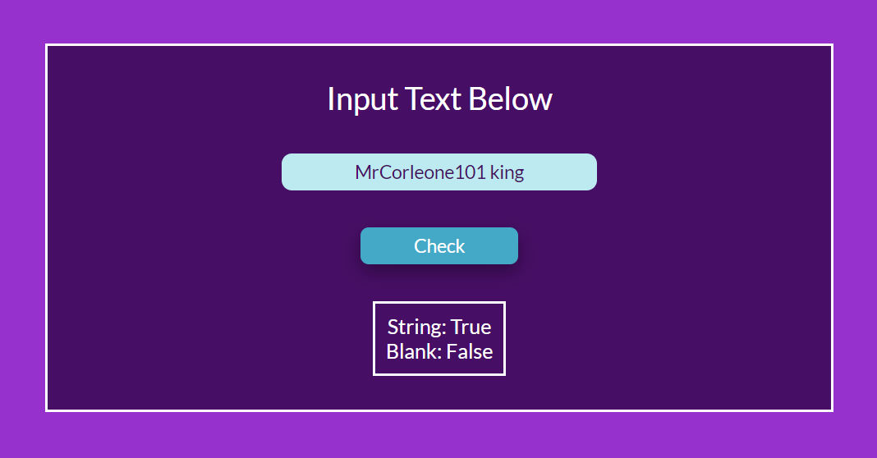

**CONCLUSION:**

Through this experiment, different JavaScript functions were understood.